The Git & Github Bootcamp
https://git-scm.com

Course Curriculum
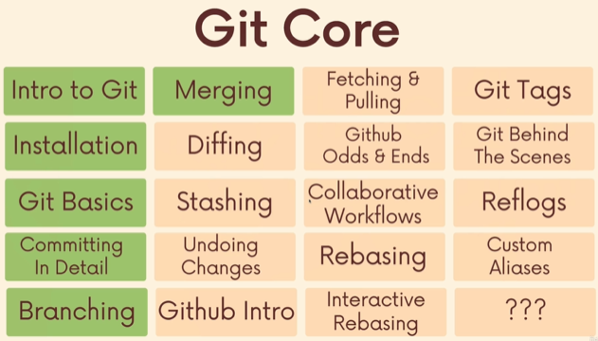

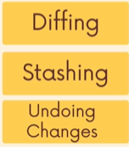

What exactly is git
Version control system. Version control is software that tracks and manages changes to files over time.
Manage,track,undo,merge,compare,sharing
Version Control systems generally allow users to visit earlier version of the files, compare changes between versions, undo changes, and whole lot of more.
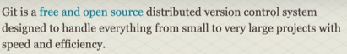

Visualizing Git
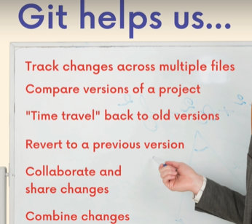

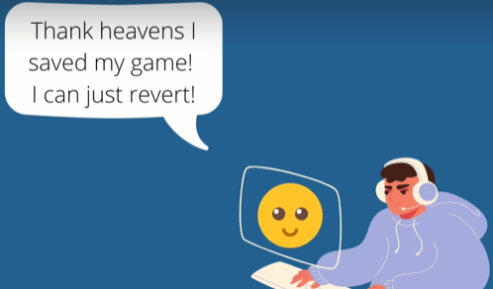

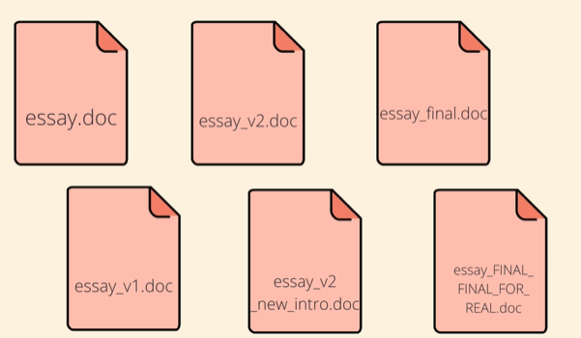

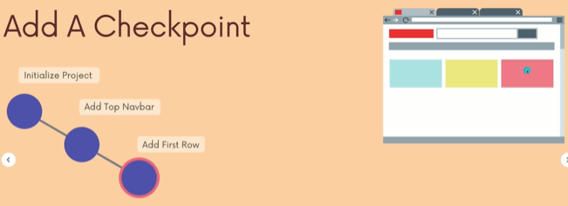

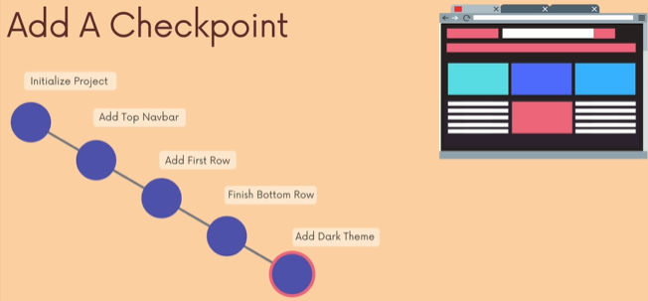

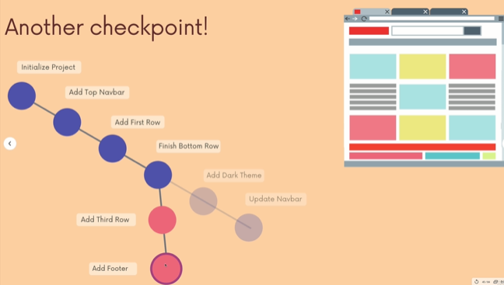

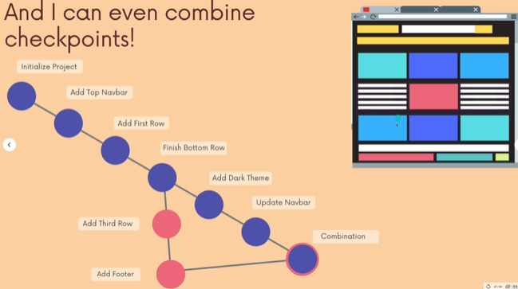

Git vs Github : Whats the difference?
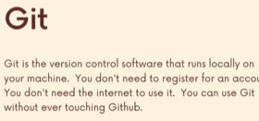


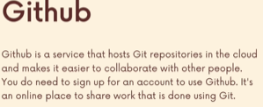


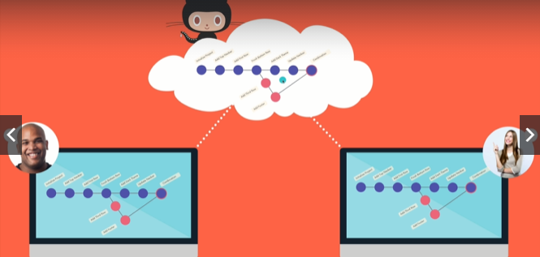

Installation and setup
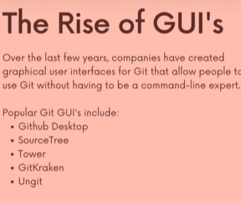

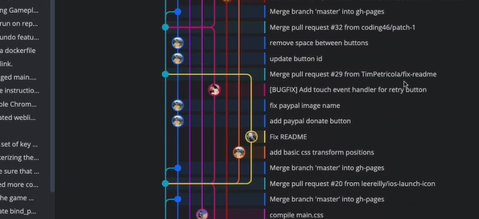

Configuring Your Git Name & Email.
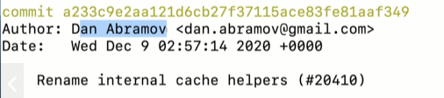

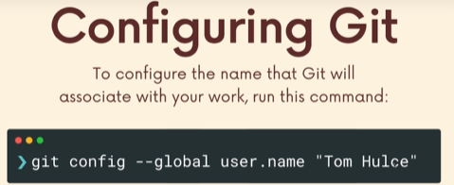
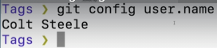

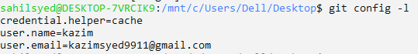

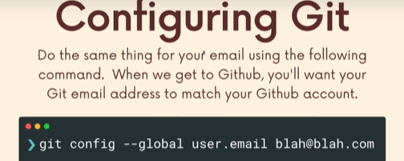

Installing Git Kraken

The Very Basics of Git, adding and commiting

What is Git repo:
I have git, but I have to manually tell git when I want to use it.
Aka I have to create repositories.
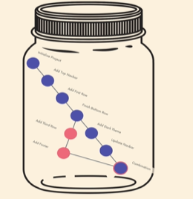

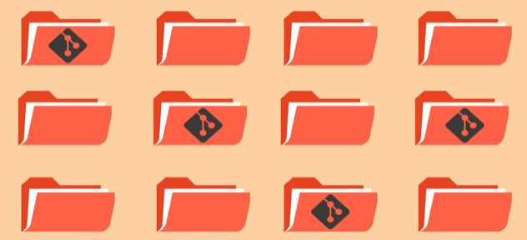

Our first commands: Git init and Git status

The Mysterious .Git folder

It will stop making it a git repository.

A Common Early Git mistake
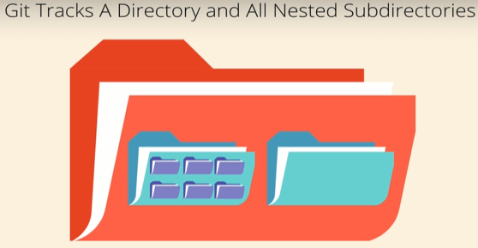

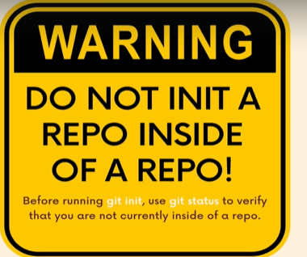
So use git status.

The committing Workflow Overview
A git commit is checkpoints in a git repository.
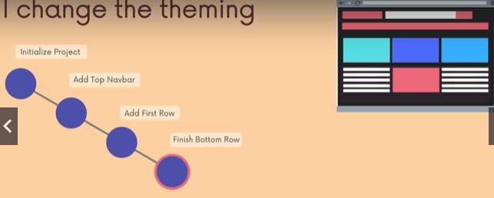

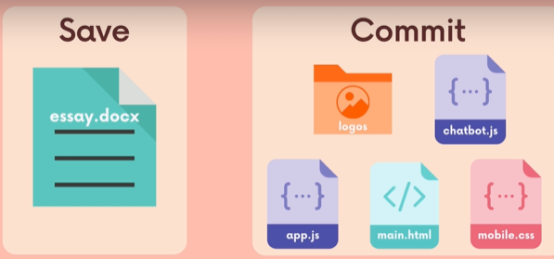

So u might one wanna do individual commit.
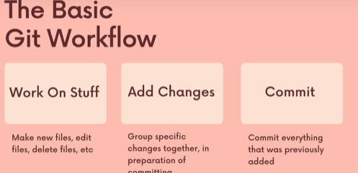

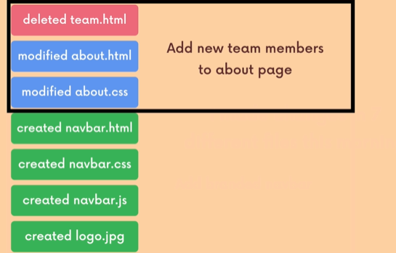

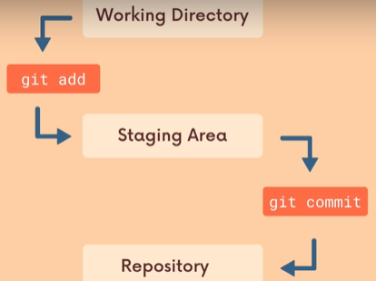

A commit is checkpoint in time, a snapshot of repository. Eventually we will be able to go back to earlier commits, undo commits, merge commits.
For now, we are focused on plotting the commits, and leaving a trail of commits behind a trail of checkpoints.
When we make a checkpoint we can call a specific changes that we want to include in a commit rather than just including all changes in our project.

Staging Changes with the git add
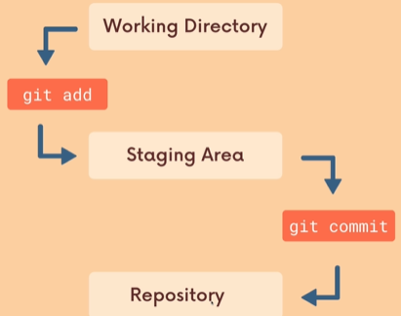
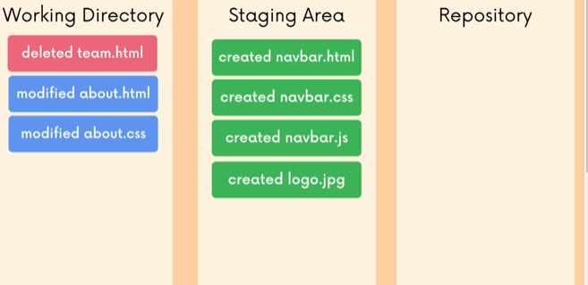
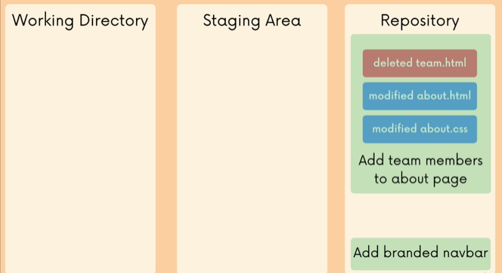

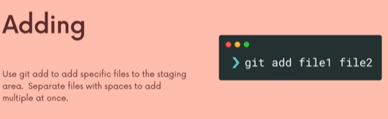

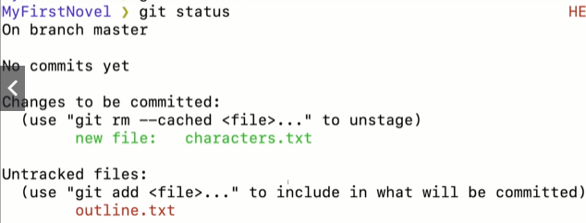

Finally, The Git Commit Command
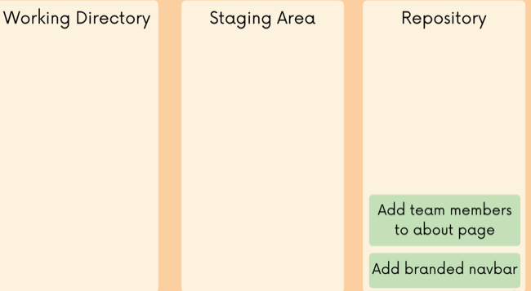
Git commit msg must summarizes the changes and work snapshotted in the commit.
> git commit
it will open the defualt editor
> git commit -m “”

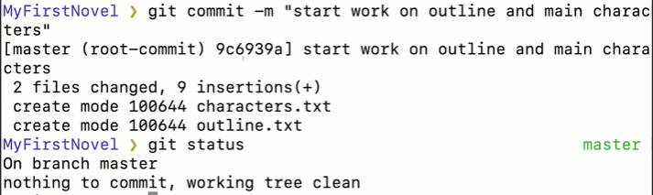
it means everything in sync.
Everything in your working directory, git knows about and git is been tracking and its up to date.

The Git log command
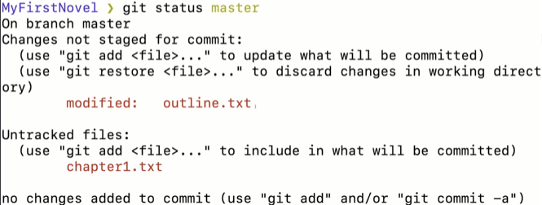
Kazim words:
The both red files are updated or deleted or moved from somewhere.
The modified tells git knows the previous state of the file, and see its modified.
The Untracked files says, I don’t know about that files, I am not tracking it or I don’t have a previous state of it.
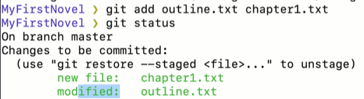

Kazim words: since both are add to the staging area, so if we revert after committing to a checkpoint, it will affect all the files.
>git log
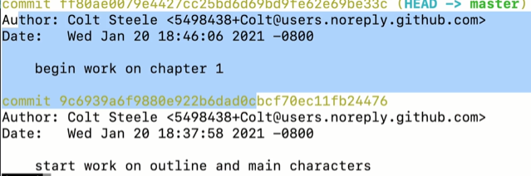

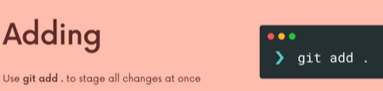

Commits in Detail (Related topics)
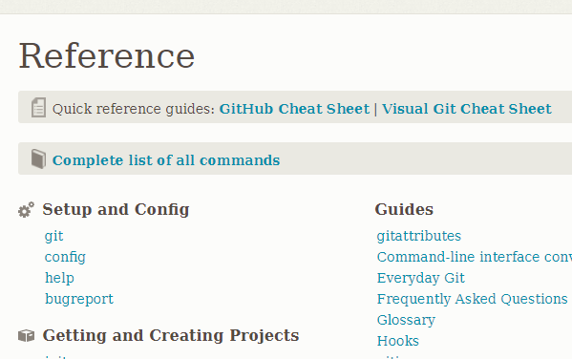
Link:Click

Keep your git atomics
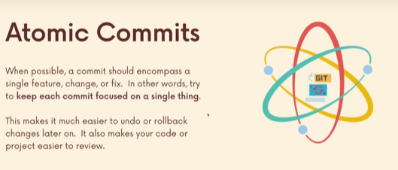

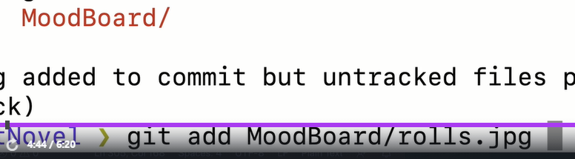

Commit Messages : Present or Past tense

A closer look at the git log command
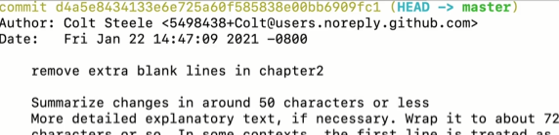
We need commit hash to revist the commit or undo a commit or checkout or take a look at a commit.
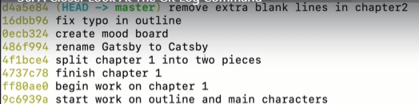

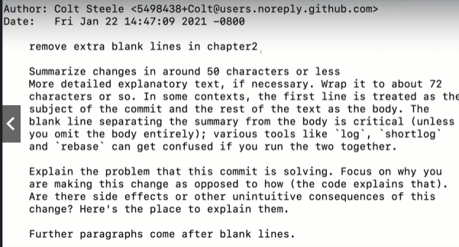

The convention is to have the first line to be the summary of the commit.

Commiting with a GUI
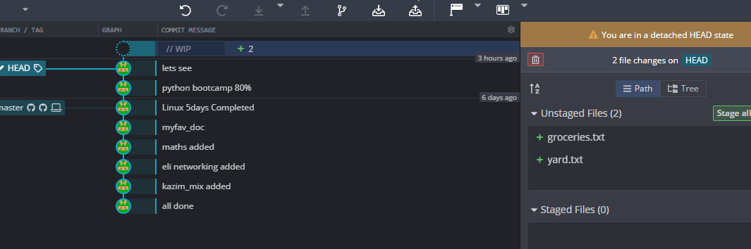
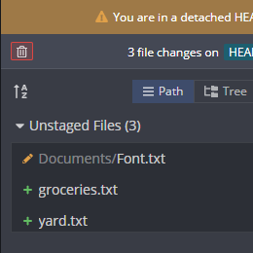
Pencils tells us I have modified that file
+ says its a new file.

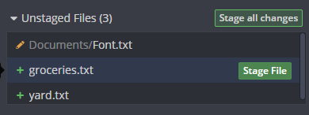
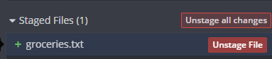

Fixing Mistakes with Amend
Occasionally when u working with gits, you realized just a moment too late. You forgot to include a relevant file in the commit.
Or you made a typo or mistake in the commit msg.
Ammend a commit, this just allow us to do redo just the previous commit.
It doesn’t work if u made a mistake 10 commits ago.
It works only when u made a mistake one commit ago.
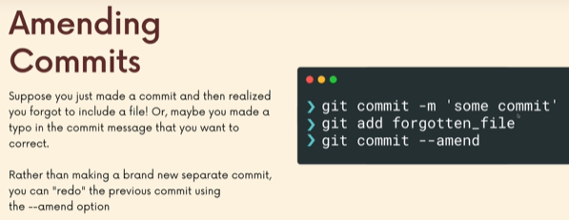
Above, for the last commit there is no commit message. Bcoz its bind with the last commit. But it automatically opens the vs code and lets u edit too. Since we just wanna add our missed file, we save the file and close it.

Ignoring files with .gitignore
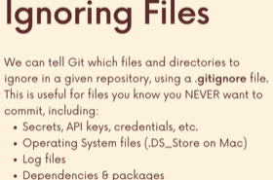

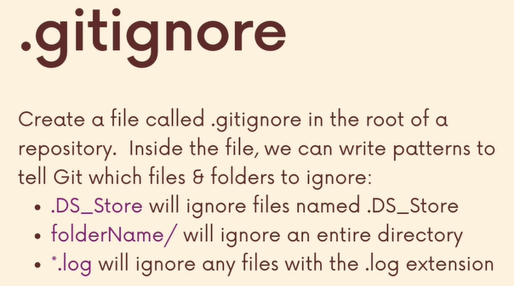

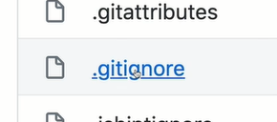
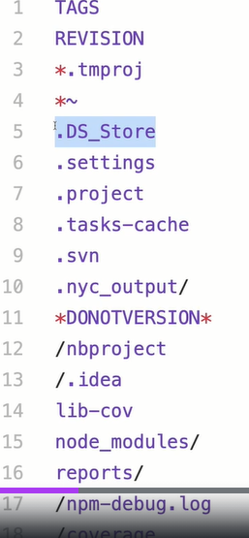

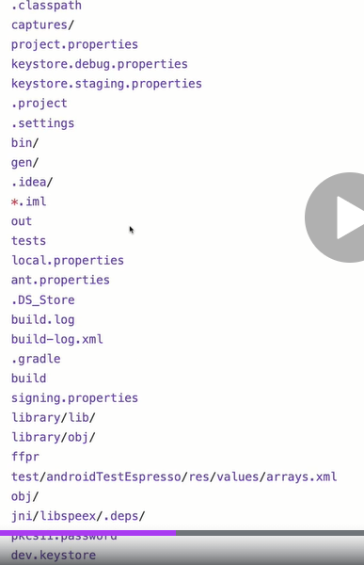

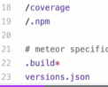

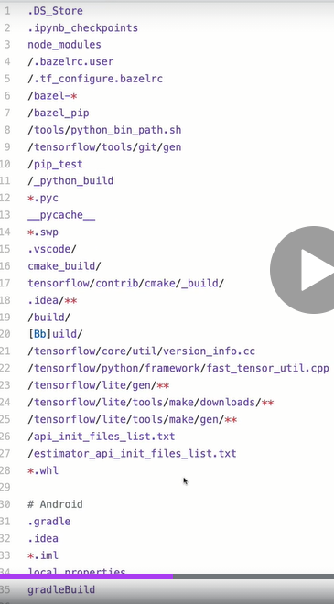

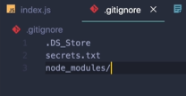
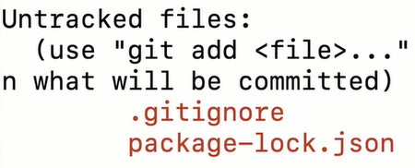

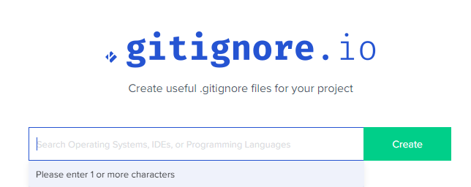
Link: Click

Working with branches

Introducing Branches
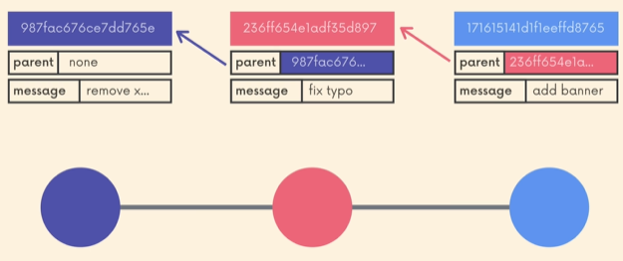

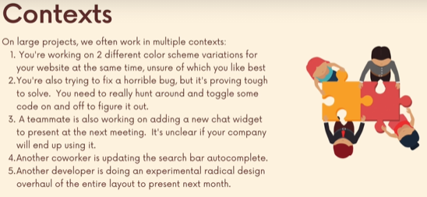

We cant work in serial fash. Its better everyone perform on a copy of their own.
Changes made by one person may break the other person code.
So they work in isolation and maybe then at somepoint, we decide to incorporate changes in each other context.
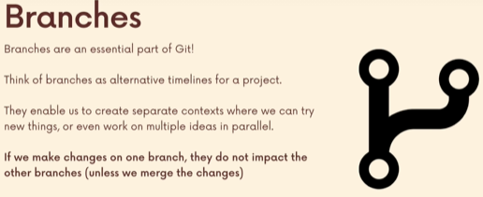

So changes in one branch wont affect the other. It may affect when we merge. But after we decide to merge then.
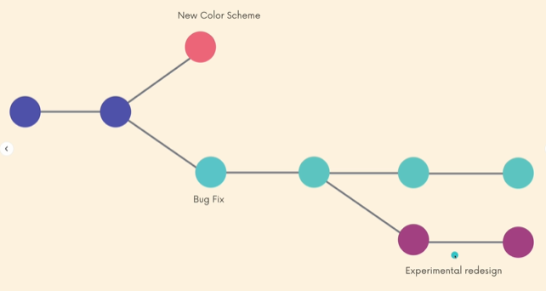

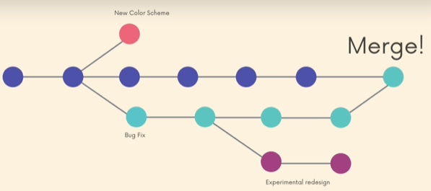

The Master Branch ( or is it Main)
In git, we always working on a branch.
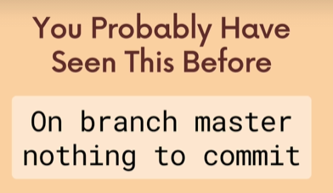

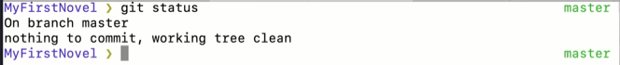

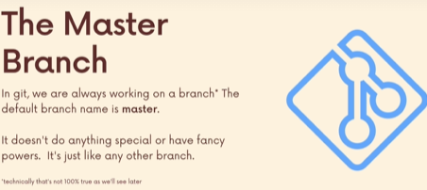

The branch we start on is called Master. Every single branch you create has the same abilities. It has nothing special about it, except it is made for you.
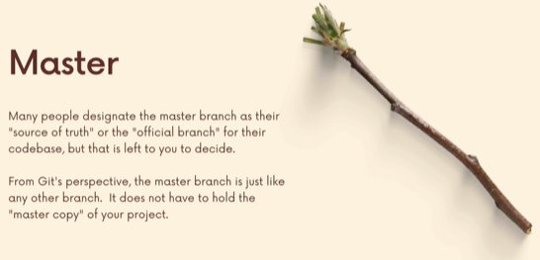
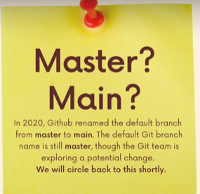

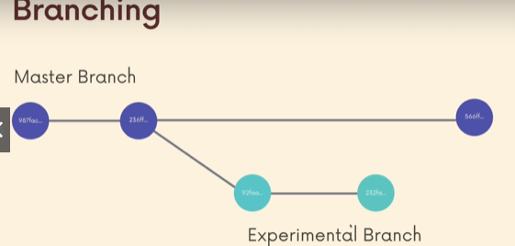
Abandon the feature branch.

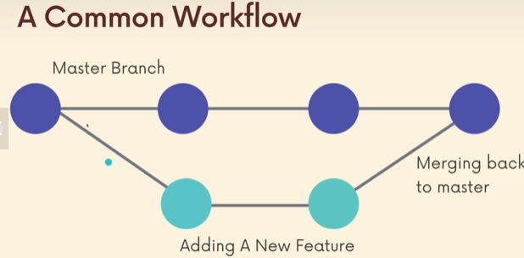

What on earth is Head?

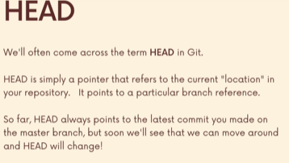


The different colors represent different people are reading the book. Only one of the spots can be open. Only one can be active or read.

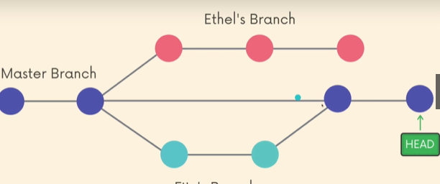

if we havent made any branches, then the Head is always referring to master branch or the last commit on our master branch.
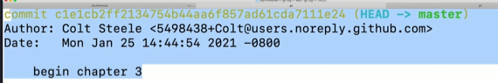

If I had more branches, if I switch to a different branch. For e.g Ethel’s branch.
Head points to Ethel’s branch
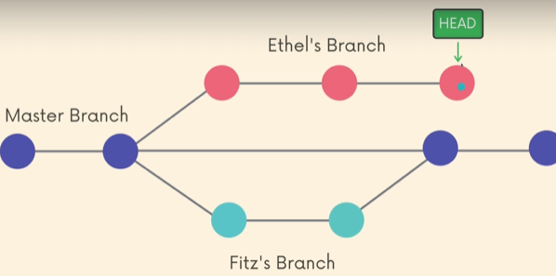

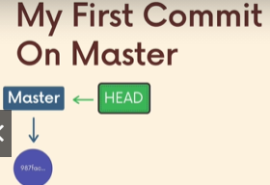
Head is a pointer, it is a reference to a branch pointer. A branch pointer is where a branch is currently is. Its like a bookmark in a book.
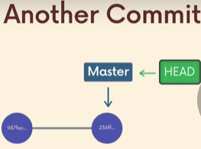
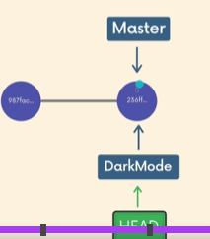

the right image, the dark mode refers to the same point as master.
Head points to the dark mode, which tells I am on the dark mode branch.
Now, if I do a new commit and do some new work.
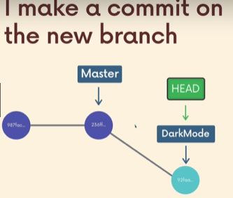
Master stay where it was, darkmode refers to a new commit, and the head still points to the dark mode.

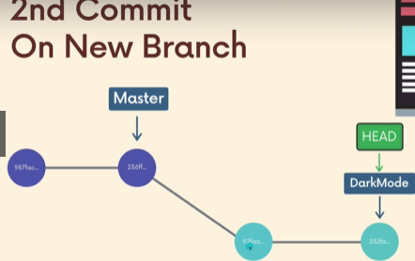

We can switch back to any point, we can go back to master, we think of it as a bookmark in a book. We still have that bookmark, That was this reference is.
I can open that page by switching over to this branch.
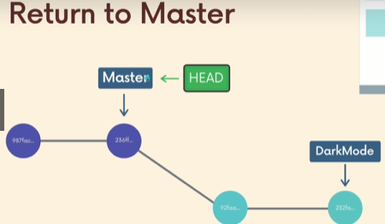
We can have 100 of this branches, each branch has a reference telling where we left off.

Viewing All branches with Git branch
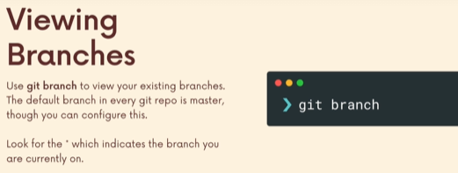
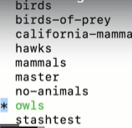

Creating & Switching Branches
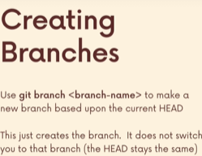
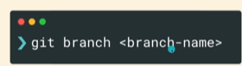

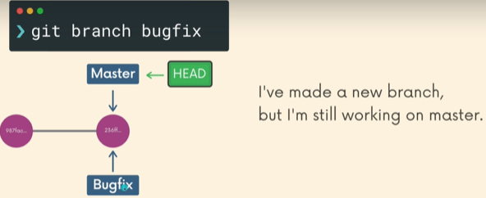

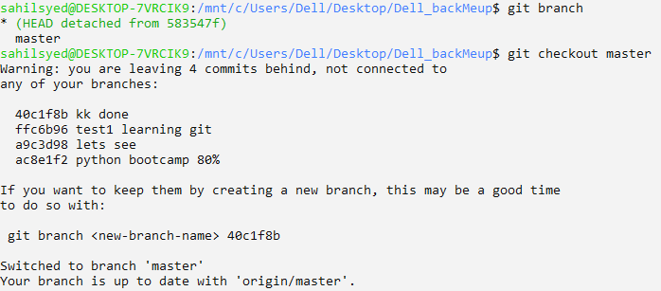
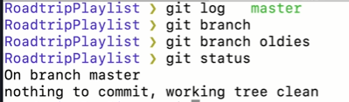
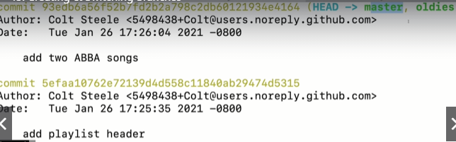

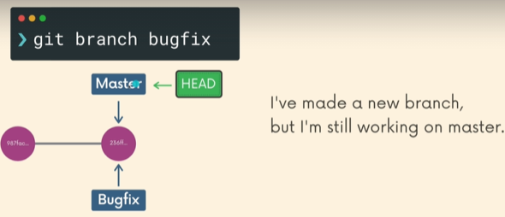
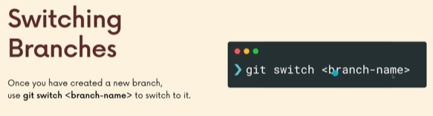
the older command was git checkout.
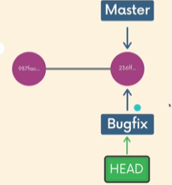

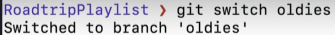

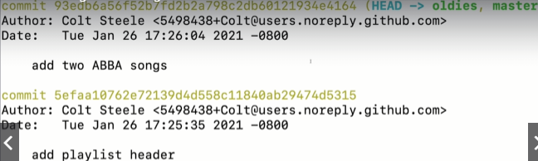

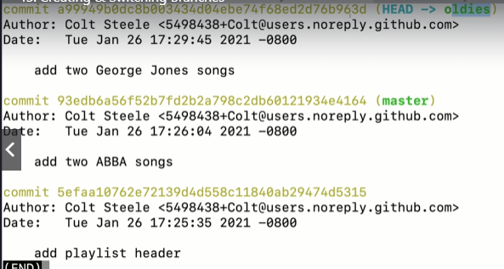
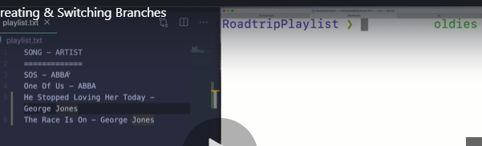
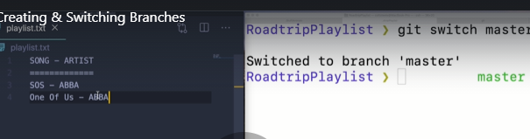
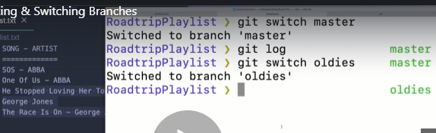

More Practice with branching
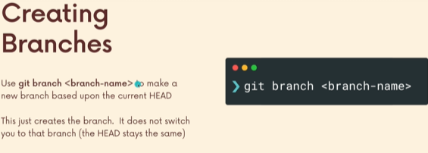

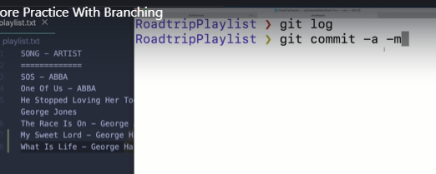

-a is used to add all unstage changes or aka all.

Another way of switching
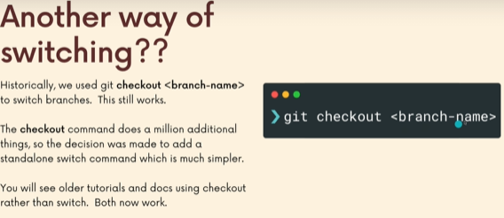
It does a lot more than switching branch. Its like swiss army knife of git.
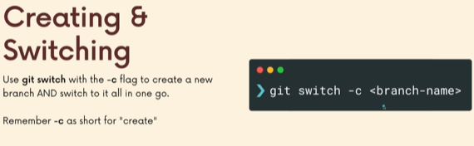
git checkout b <branch-name>

Switching branches with Unstaged Changes
So if I am on a branch and I have some work that is not currently commited and I switch to another branch.
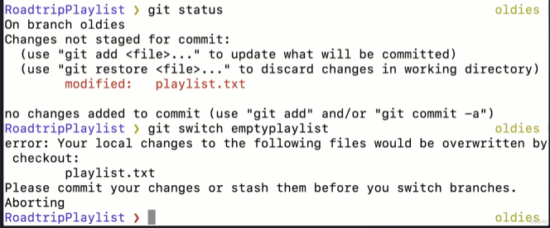
If I try to switch to another branch, the unsaved changes will be lost.
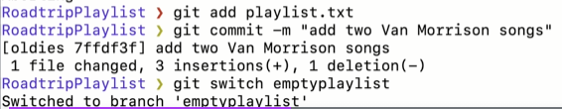
So,

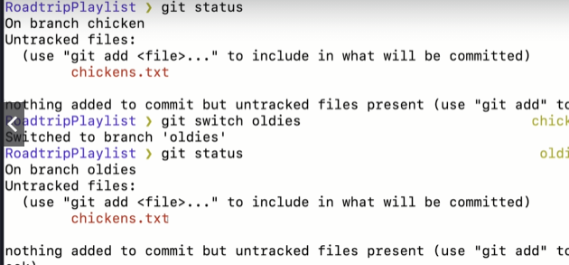
The above, the reason we able to switch to another branch while holding some unsaved changes in working directory. Cuz it was unique file, other branches don’t have that file. You can tell bcoz there is no modified keyword.
The reason the conflict was when we switch we may see the oldversion of the file, since this file was fresh new, we didn’t lose the information, its still as it is in working directory. Waiting to be staged and commited and create a checkpoint.

Deleting and Renaming branches
If you work professionally on a project where there is ton of branches, and you are constantly making new branches and merging them in.
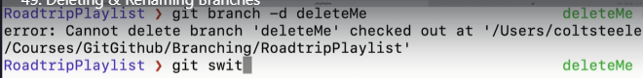
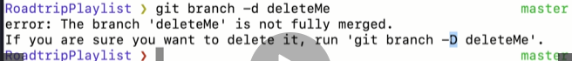

To rename a branch:
which we will be definitely doing when we proceed to github, that is rename the master branch to main.
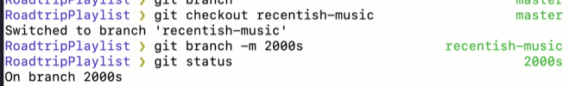
You have to be on the branch to rename it.
-m for move

How Git stores Head & Branches
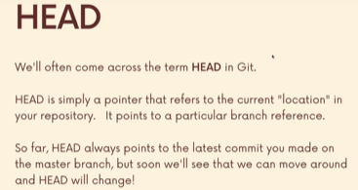

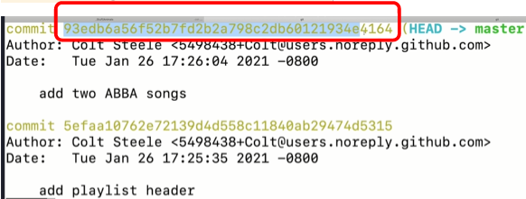

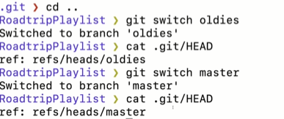

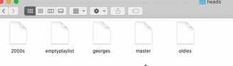

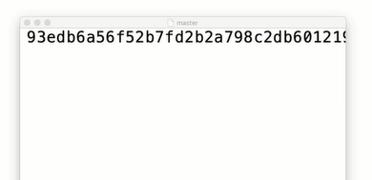

its just a pointer to a particular commit.
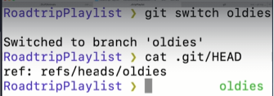

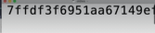

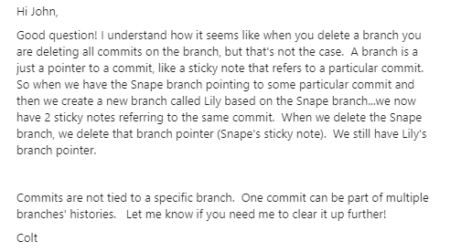
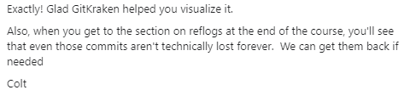

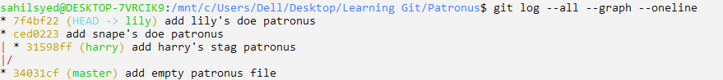
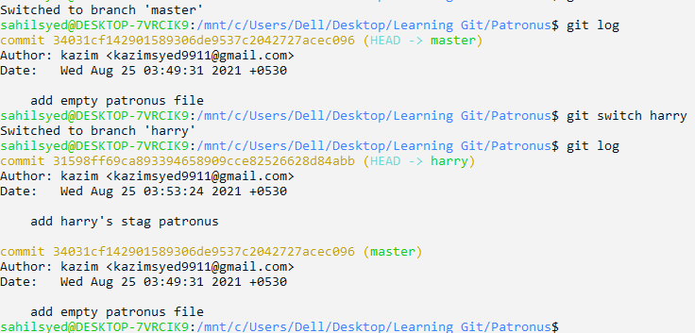

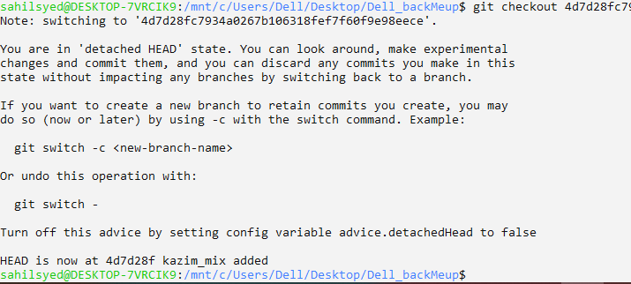

Merging branches, oh boy

An introduction to merging
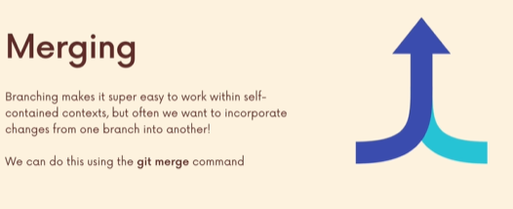

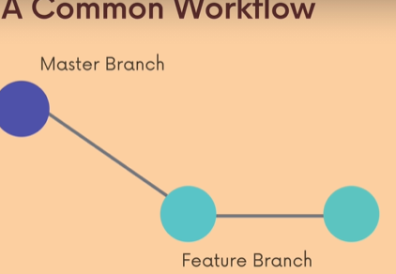
So, there is a command we use, call the git merge. A very common work flow, is to treat the master branch, main branch, trunk as the source of truth or the most stable build of the application. Where we don’t wanna screw it up. We don’t wanna do any experiments on master. So people work on feature branch.
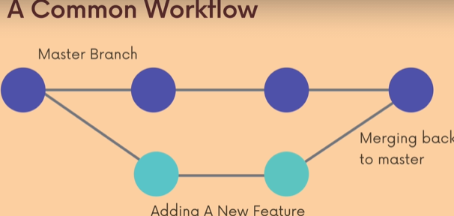
The work will be incorporated back into master branch if its deemed appropriate or solid. Its gone through different checks and people like it.
We can merge it back to master.
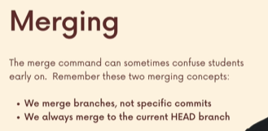

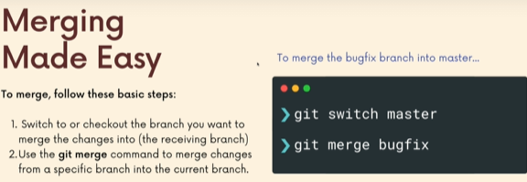
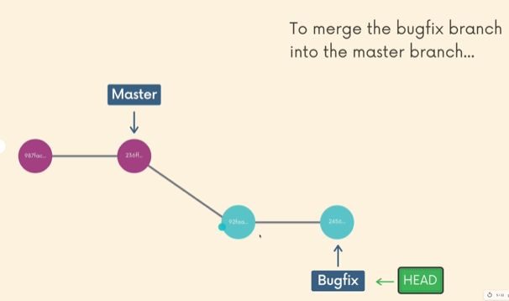
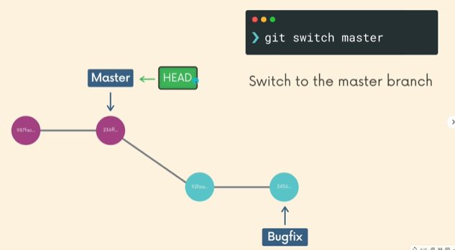

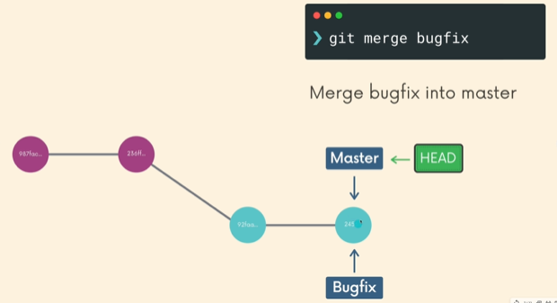

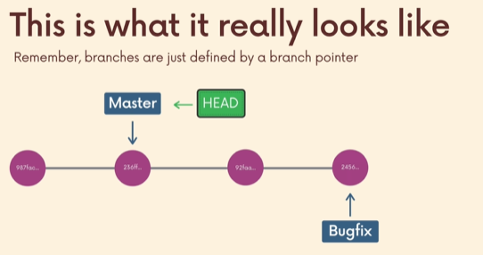
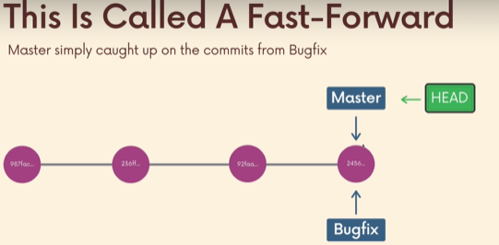

Its called fast-foward merge, since when we deviate from the master branch and made two commits, the master branch stayed the same. What it needs to only to do is update itself to feature branch.

Performing A fast Foward Merge
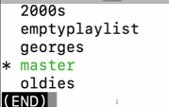
After performing a fast forward merge, its not like they both are the same branch, we can still go to oldies and perform something new and it wont exist in master. So they are not forever in sync.

Visualizing merges
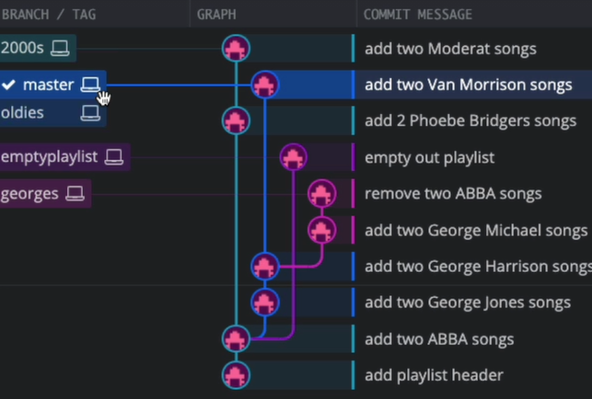

Below oldies is one comit away from master, fast forward merge will work.
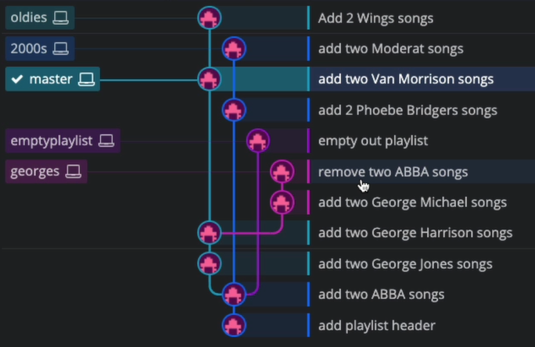

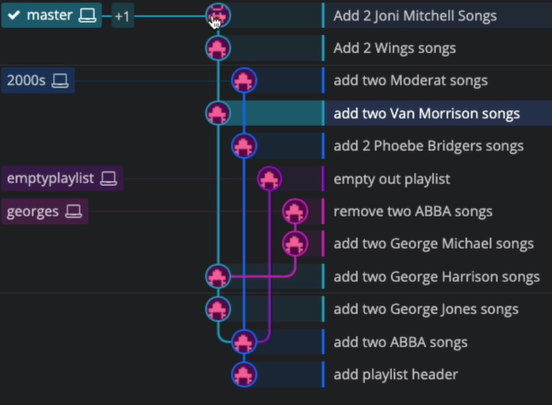
Here the +1 tells its Master and oldies branch in sync now.

Generating Merge commits
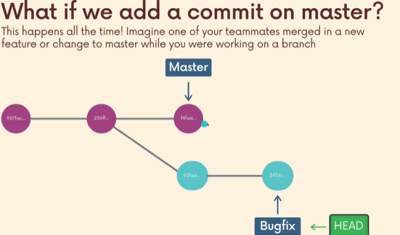

Above, we are working on a branch and we are happy with it, now we gonna merge it to master, but somebody has already perform work in master branch. Maybe a single commit or 10 commits. That we don’t have on our branch Bugfix but it is on master.
It it still the same commands, but the git may not be able to do. It depends on the particular commits and whether it has conflicting information.
For e.g on branch master on some file x, at line 59 he edited something.
And I on the same file x, at line 59 have edited something too.
There is gonna be a conflict.
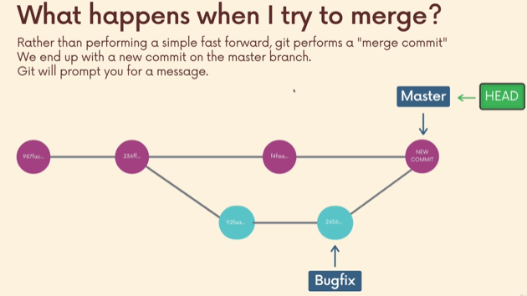

merge commit : basically git just made a commit for us on the branch we merging into ( the recipient branch). It will make a new commit for us, and it will prompt us to include a message.
You will see, the merge-commit has 2 different parent commits.
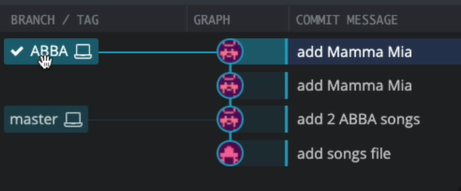

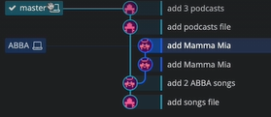

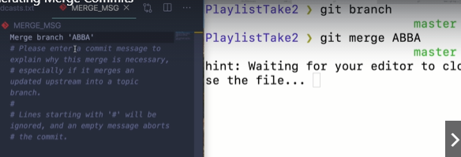

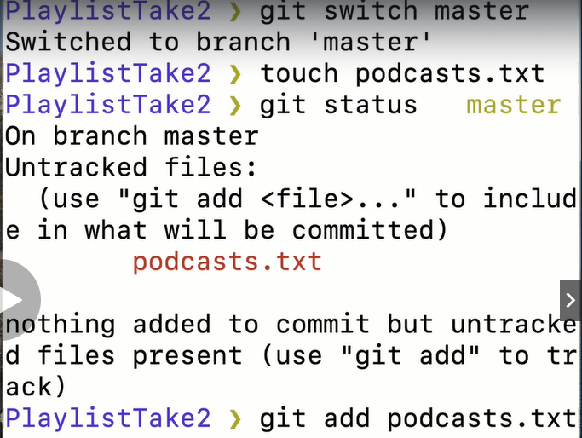
Here we working on a new file, which only master have and ABBA don’t.

Kk so, merge commit only works when new file, easy peasy for git.
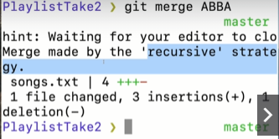

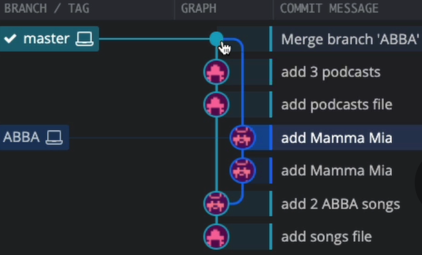

Oh No! Merge Conflicts
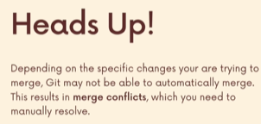

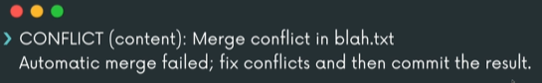

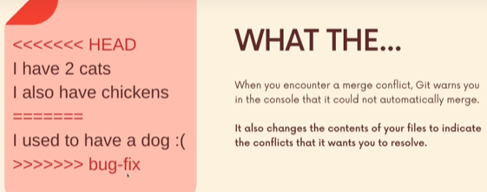

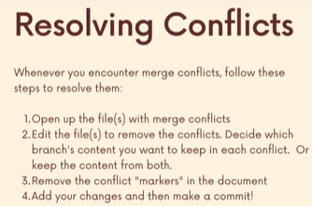

Resolving Merge conflicts
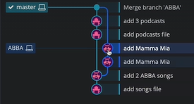

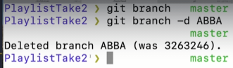

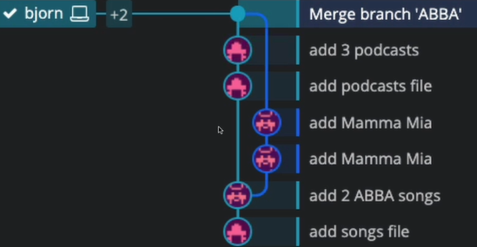

The new two branches for a song playlist along with master is bjorn, serena.

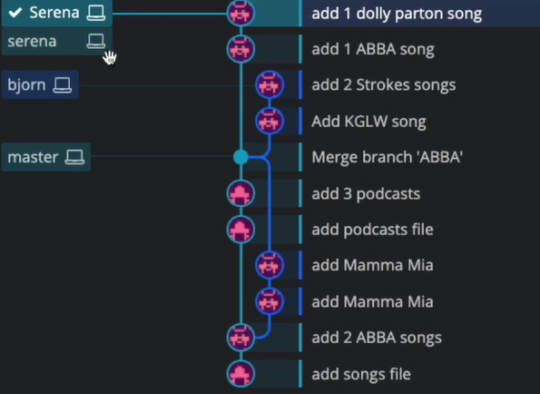

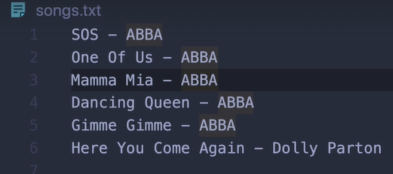

Above serena, below bjorn
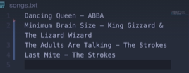

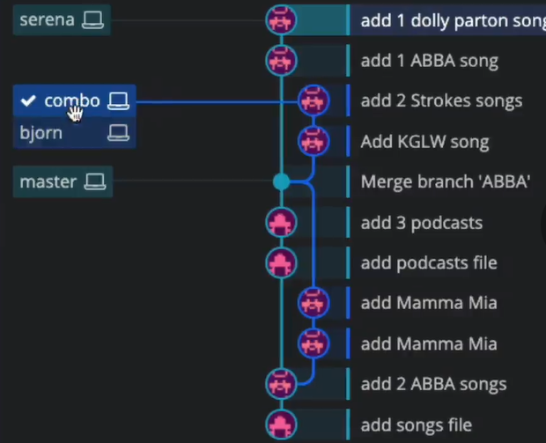

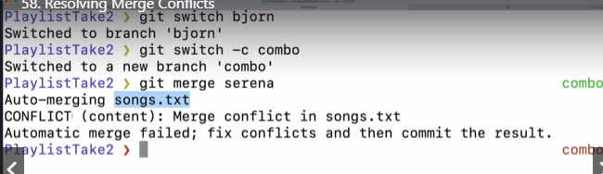
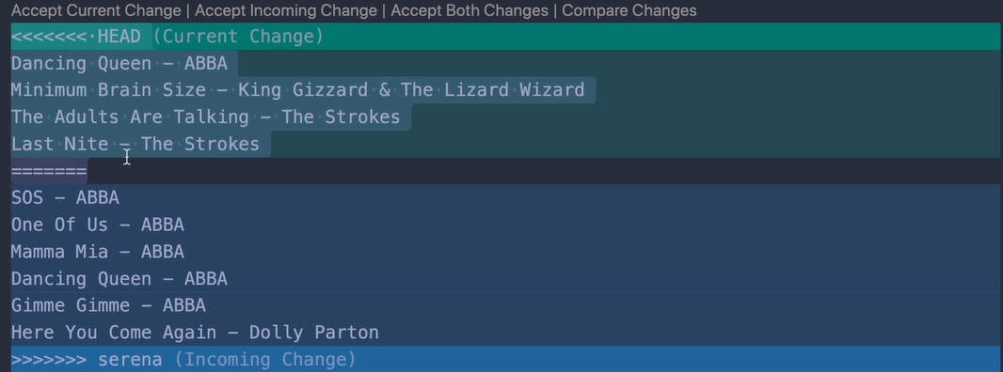

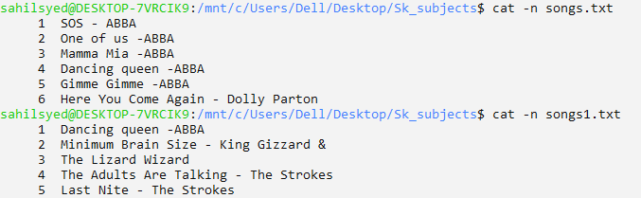
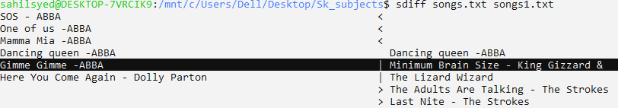

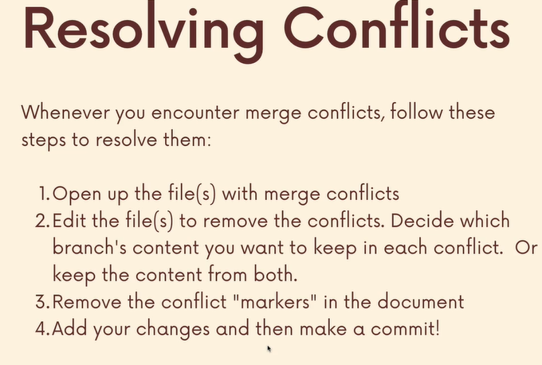

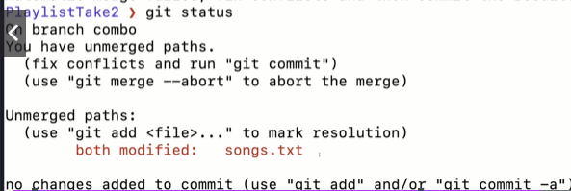
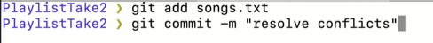

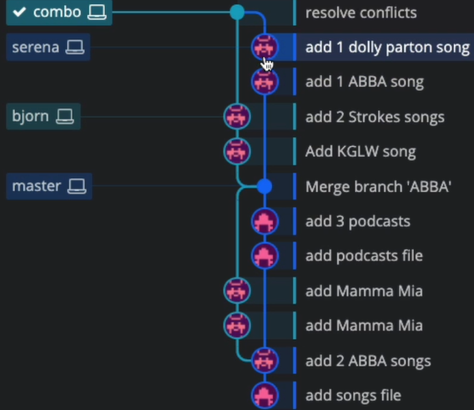

Using VSCode To Resolve Conflicts
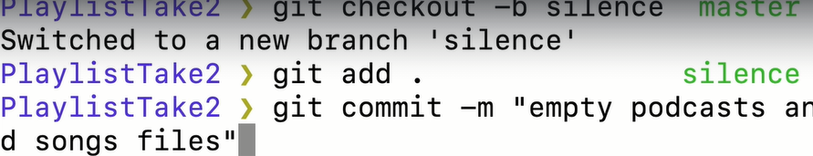
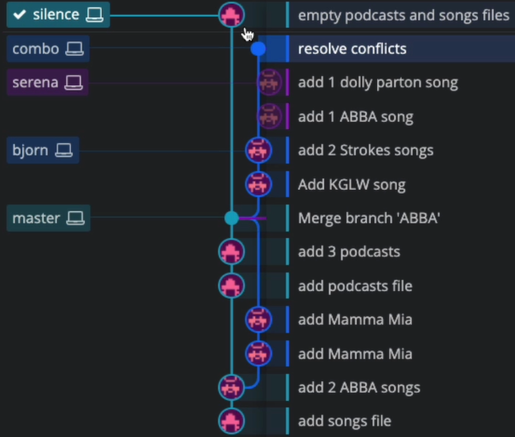
Recap:
From master, we had serena,bjorn branches. From bjorn we create combo branch. Then we merge combo and serena branch.
Now from master we created, silence.

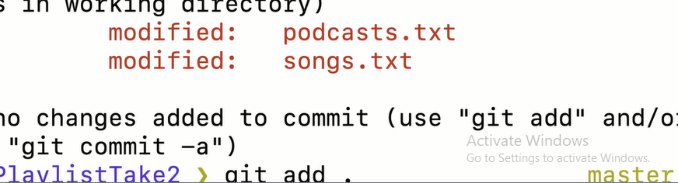

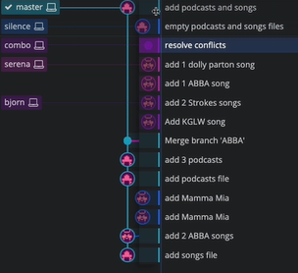
Here, we did a our very first commit in master branch since a long time ago.

Now, we gonna try to merge silence and Master.
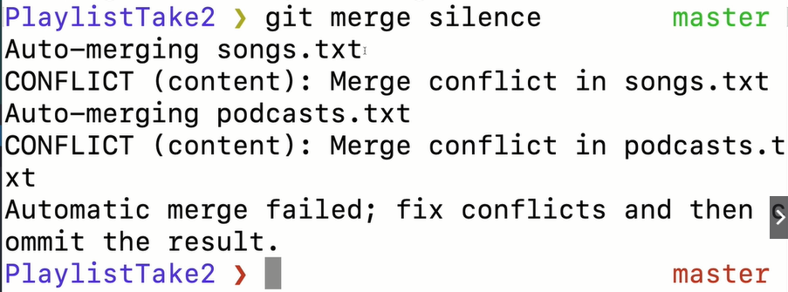
Vs code has a built in interface.
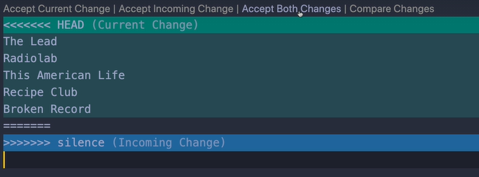
Above current change represent the head, we r on, which we want to sync with incoming changes which is silence here.
Sometimes when resolving conflicts, you may add additional code for e.g comments.
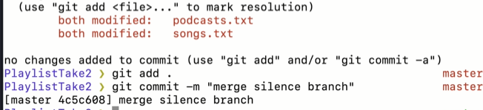

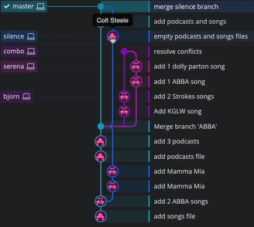

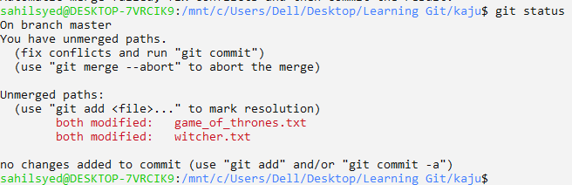

Merging exercise Self-study
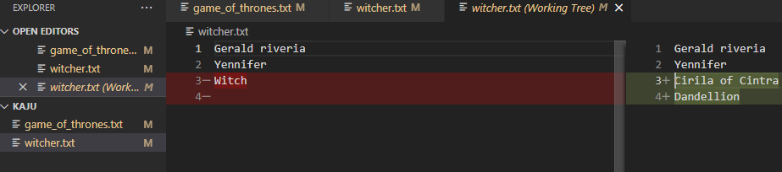
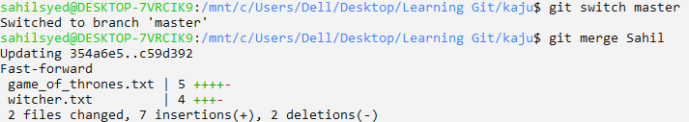
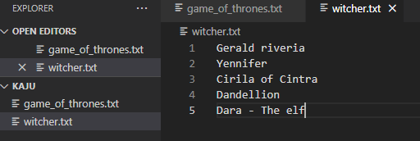

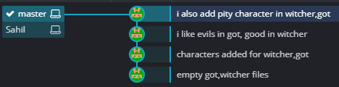

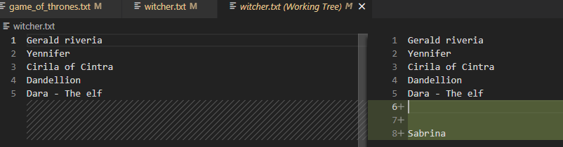

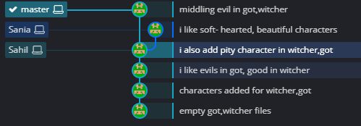

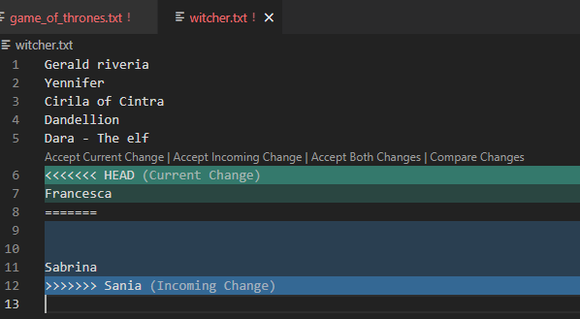

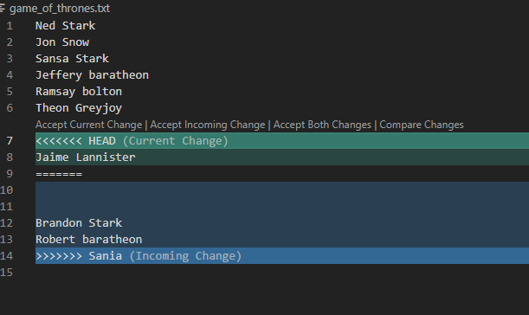

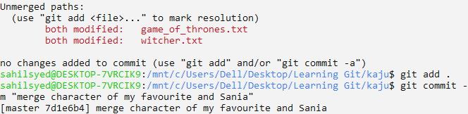
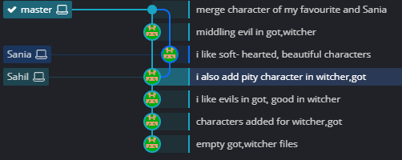

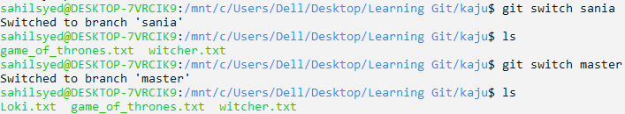
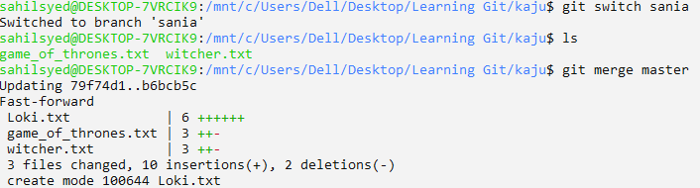

Comparing changes with git diff
Git diff helps us to make comparsion between different commits, different branches, between different files, between the staging area, the working directory, 2 different files over a certain number of commits.
Whats changed between what we have locally versus whats on Github.

Introduction The Git diff Command
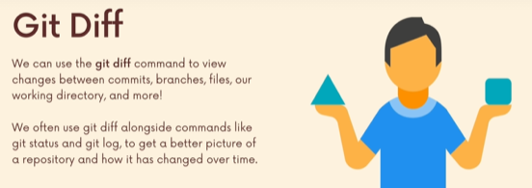

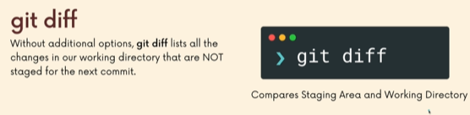

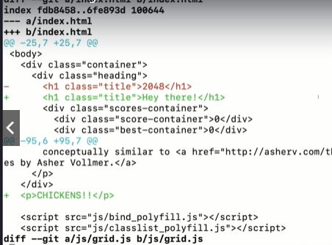

We see ---, +++, -, + ,-25, +25, @@, Red color, green color.

A Guide To Reading Diffs

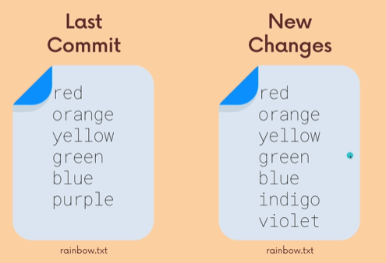

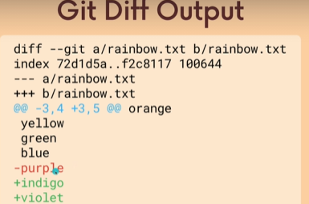

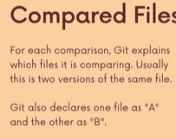

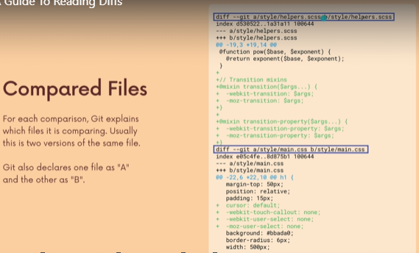

The second line is the metadata about the file. And internal mode identifier.
Not important.
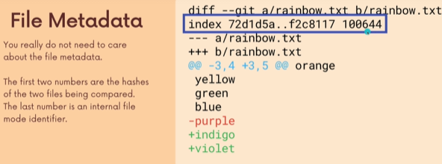
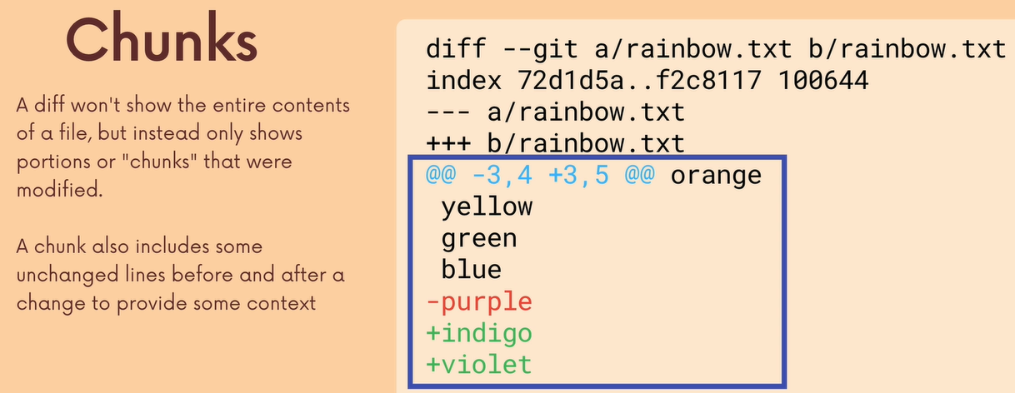

it gives some other text to give, context of where it is. There is no black text below green color cuz its eof.
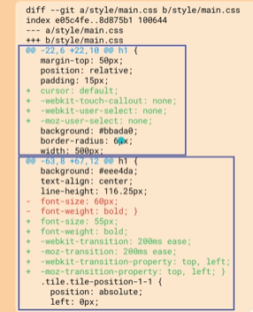

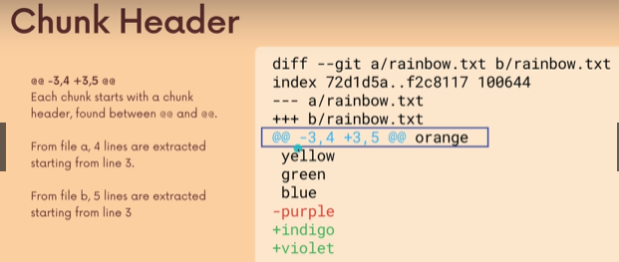

Chunk header is at the begining of each chunk. There are two pairs of numbers.
- represent file a, + represent file b.
Its says -3,4.
start,end = 3, 3+4-1= [3,6]
its say +3,5.
start,end= 3, 3+5-1=[3,7] Basic it tells what lines numbers are extracted.
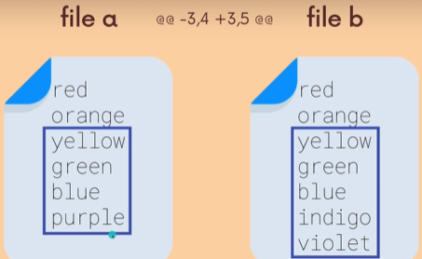

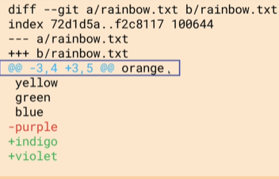
Orange , is a bit dodgy.

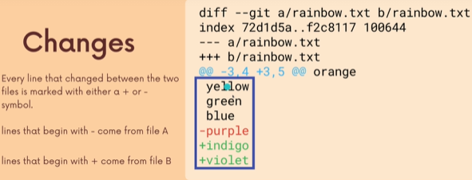
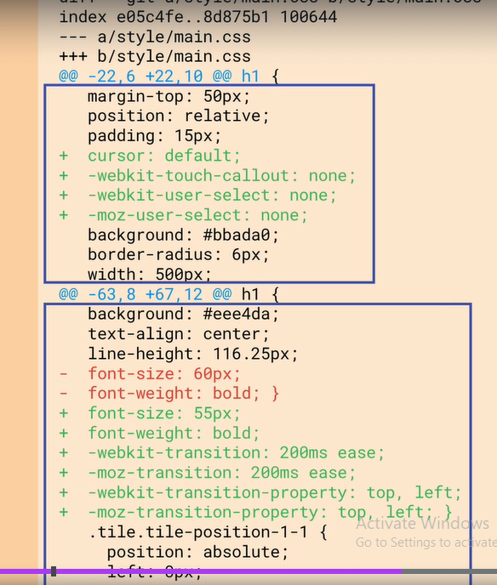
So line [22,22+6-1]
=[22,27]
len(22,27+1)=6.
So in left, we have 3 lines up and 3 lines below, for context.

So line [63,63+8-1]=[63,70]
len(63,70+1)=8.
So 5 lines up and 3 lines below.

Viewing Unstaged Changes
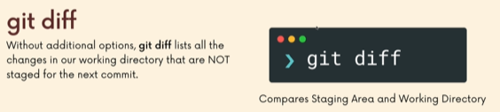

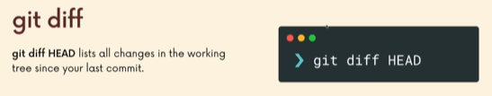
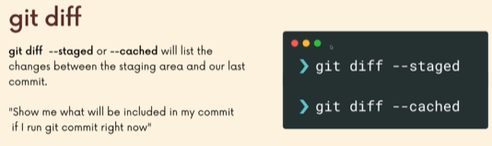

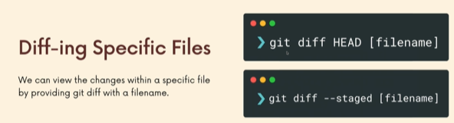

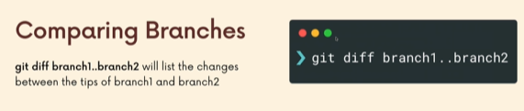
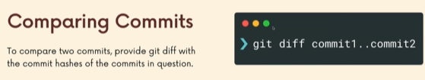

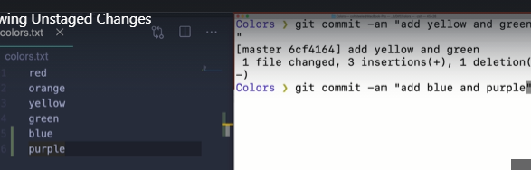
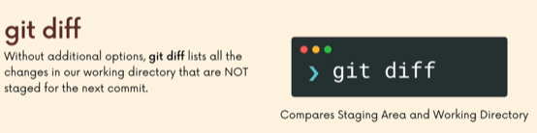
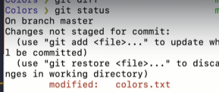

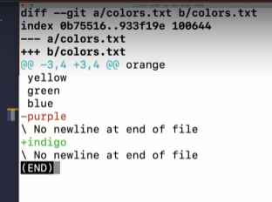
In this e.g a is the changes that the staging area knows about and b is the changes in our local directory.

Viewing Working Directory changes
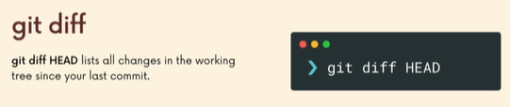

git diff: tell us the difference between our local changes and commited work.
Git diff head : tell us the difference between our (local+staged) changed and commited work.
Aka git diff head is gonna tell everything that is changed since our last commit.
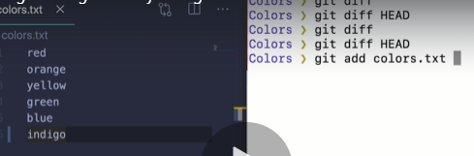

Above, just git diff wont show the changes that have occur since our last commit.
Instead use git diff HEAD .
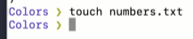
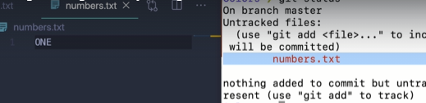

Now, again git diff wont show anything since its new and has never been commited.
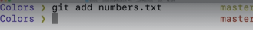

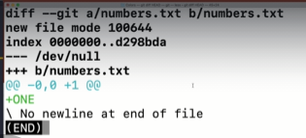

The way we can tell there was nothing there before, by seeing /dev /null
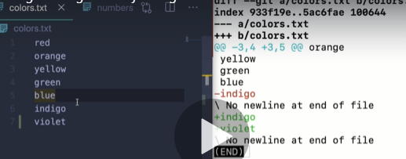

We wont see, the new file that is in the staging area rn.
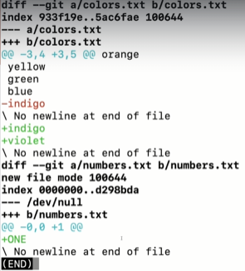
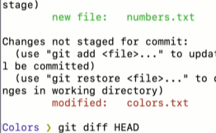

Viewing Staged Changes
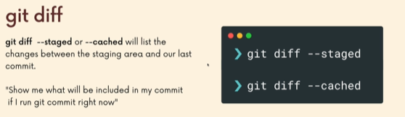
What is the difference between my last commit and my staging area.
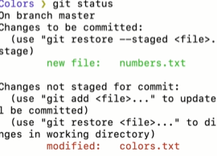

>git diff --staged
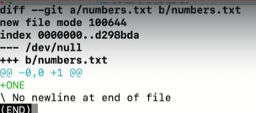

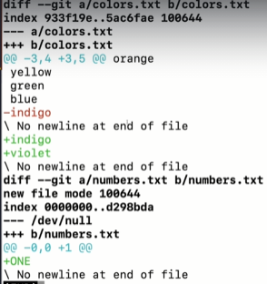

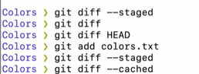

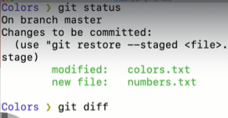
What will you see if I run git diff?
>nothing.

Diff -ing Specific files
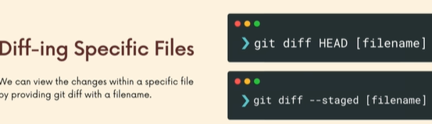



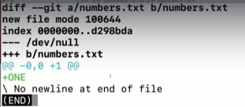

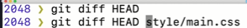

Comparing changes across Branches
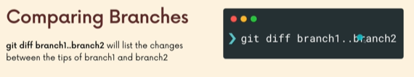
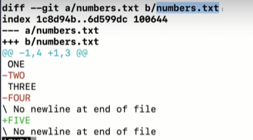
a is master branch.
B is odd-numbers branch.

Above, We can use space or .. in between branches.

Comparing Changes across Commits
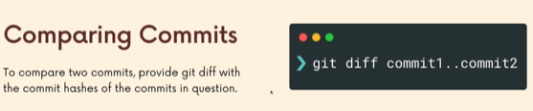

If you wanna know what changed between two commits, it can be any commit in the past.
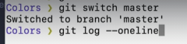
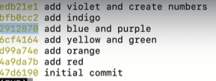

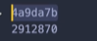
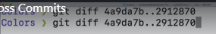

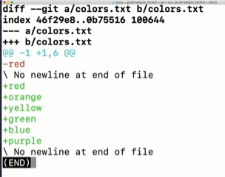

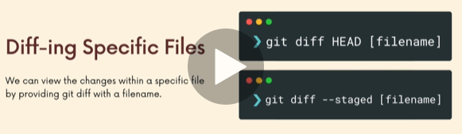
You can narrow it down for commits too.

Visualizing Diffs with GUI
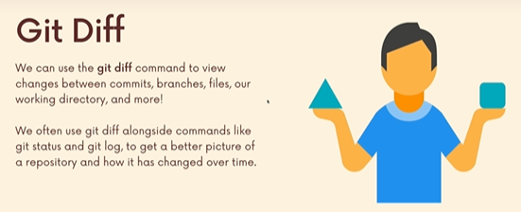

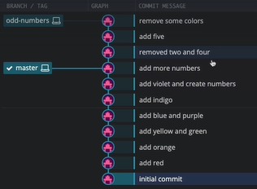
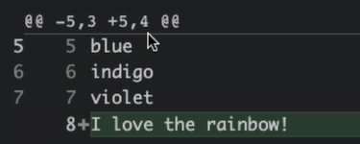
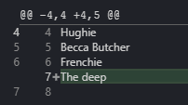

I added to Sania branch, somehow it got added to master too.
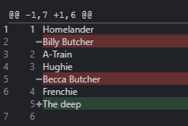
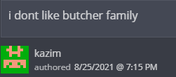

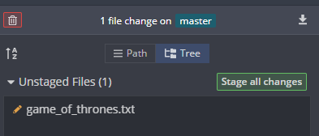

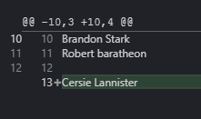

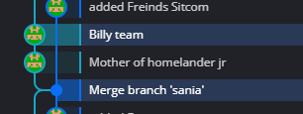
shift +click.

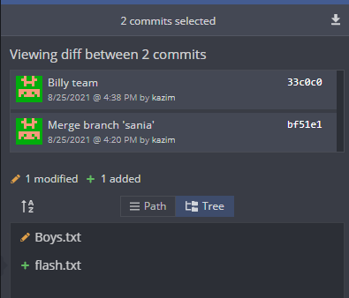

The Ins and Outs of Stashing

Why we need a Git Stash
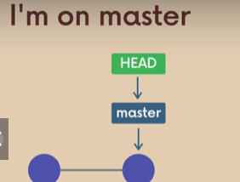
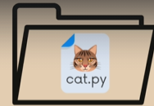

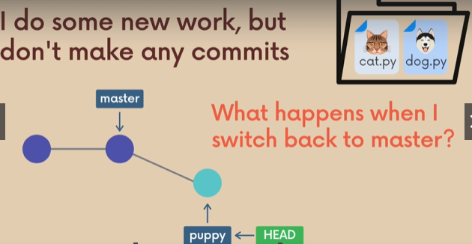

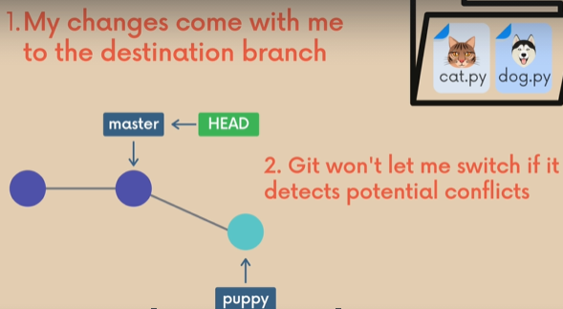

For e.g you working on a branch, but there is still a lot of work to be done. But a coworker ask for help then you have to switch.

You don’t need to wait until you make a commit on your branch because you can stash changes.
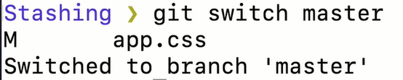

If I made changes and I don’t commit it, they came with me to the destination branch.
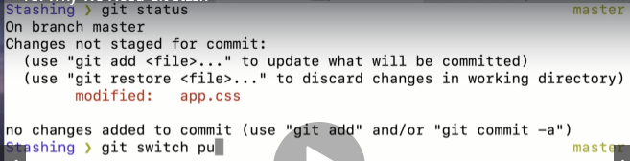
Nothing is added or comitted but.
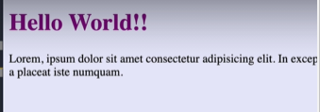

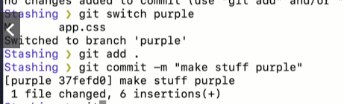
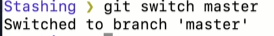
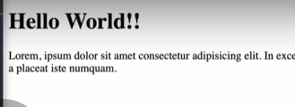

Now, we see the changes are gone.

2. Scenario: if there is a conflict, git wont let us to switch branches.
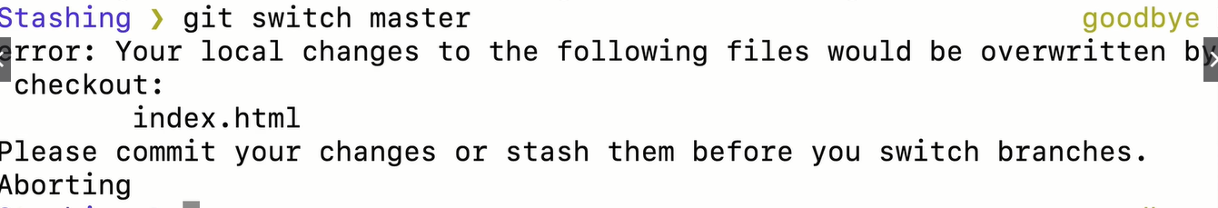

Stashing Basics: Git Stash Save & Pop
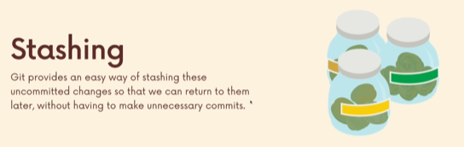

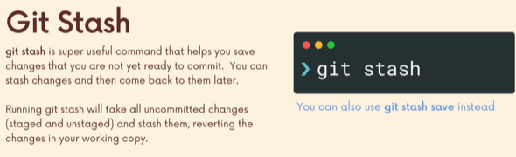

and re-apply them to your working copy or wherever i may be.

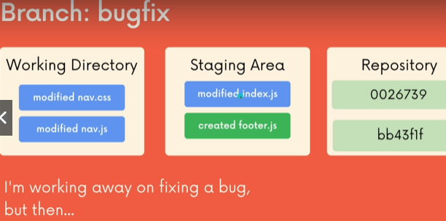
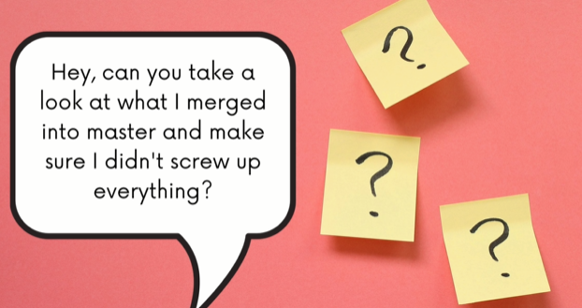

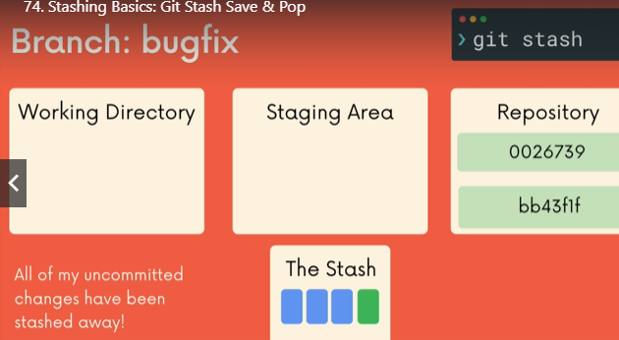

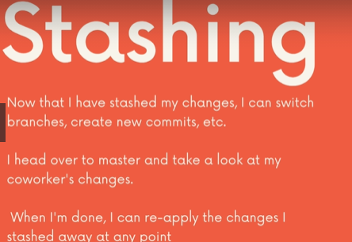

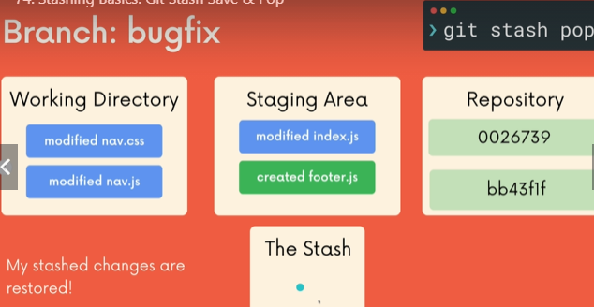
it takes the changes we have in our stash and them to our working directory and staging area.

Practicing With Git stash
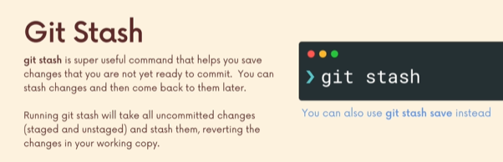
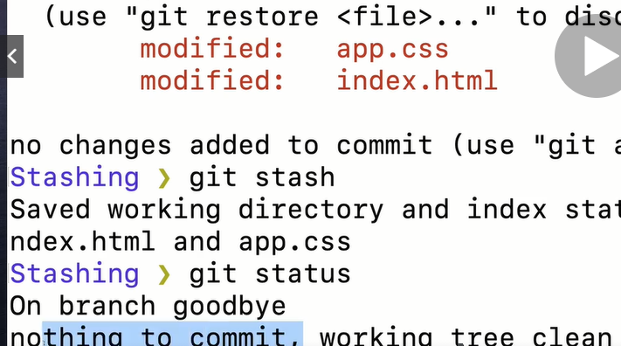

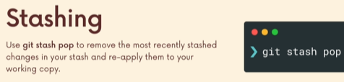

Git Stash apply
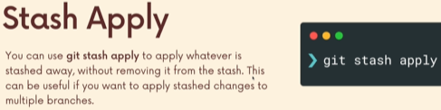

Working with Multiple stashes
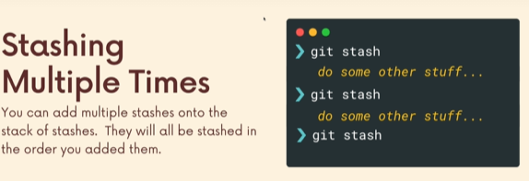

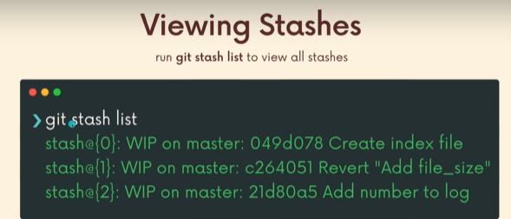

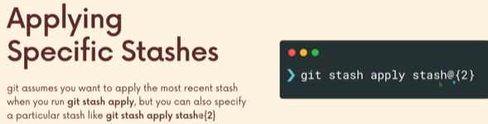
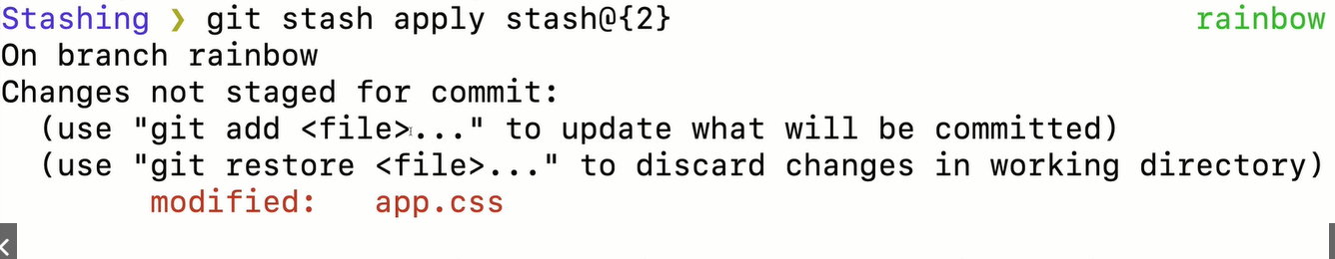

Dropping stashes
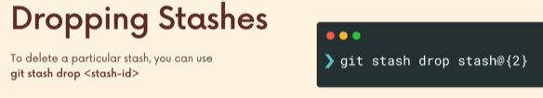
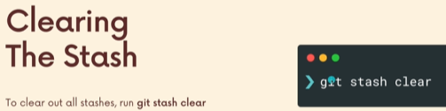

Undoing changes and Time travelling
This section helps to undo changes or go back in time or view changes from earlier.

Checking out old commits


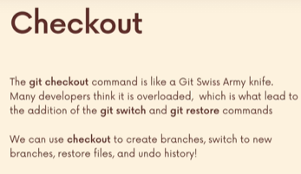

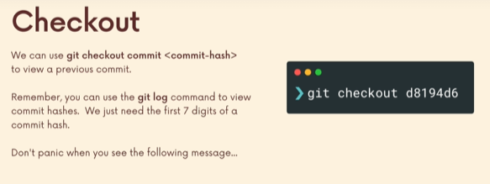
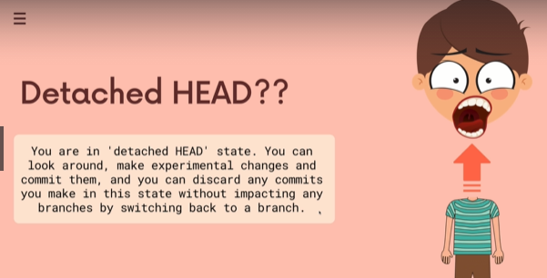

To checkout our previous commit and see what things were like.
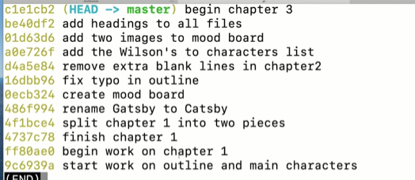
>git log – -oneline

You could use either the first 7 digits or entire thing
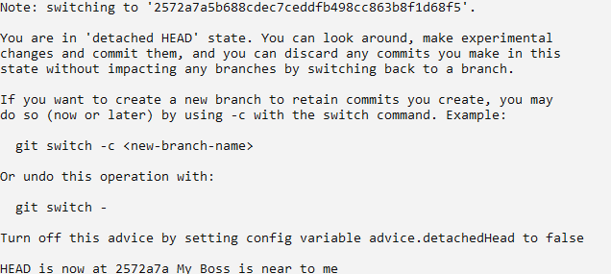
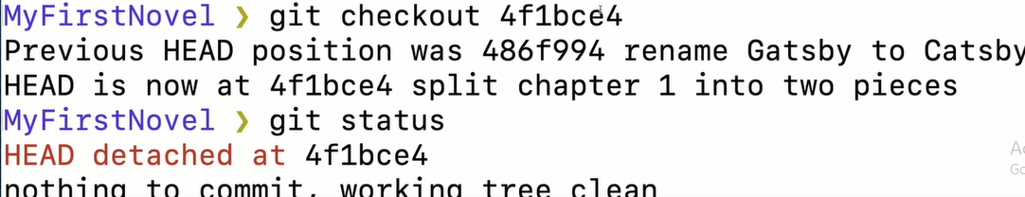

What is Detached Head?
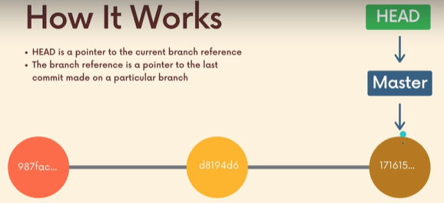

Last commit or recent commit.
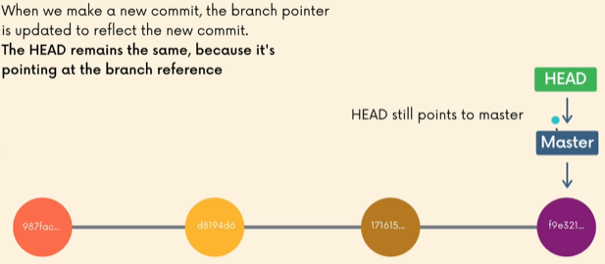

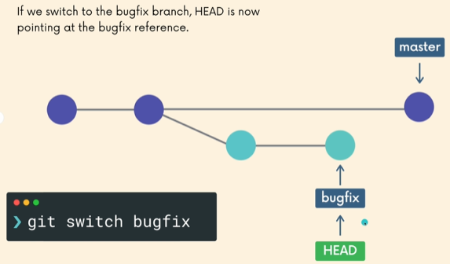

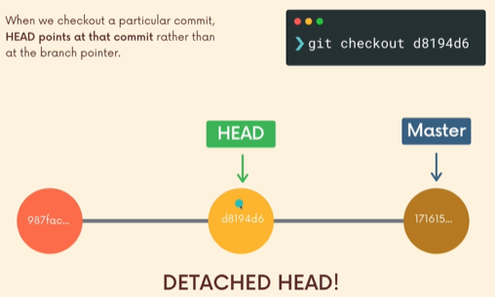

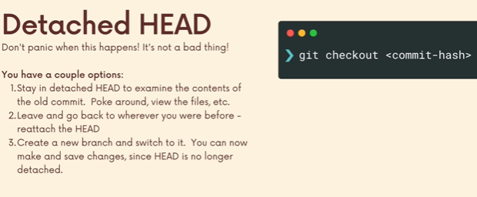
Head previously points to a branch which points to the most recent commit.

Now, head is pointing directly to a commit

Re-Attaching Our Detached Head
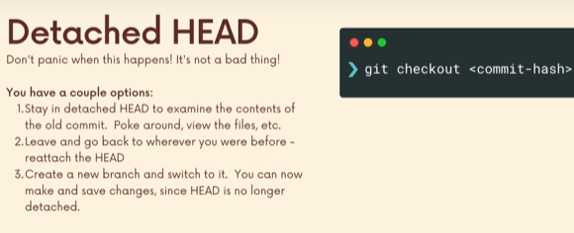
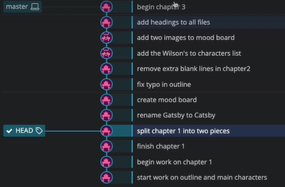

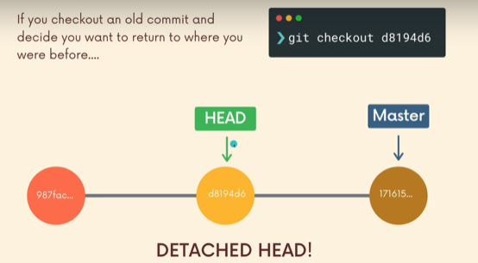
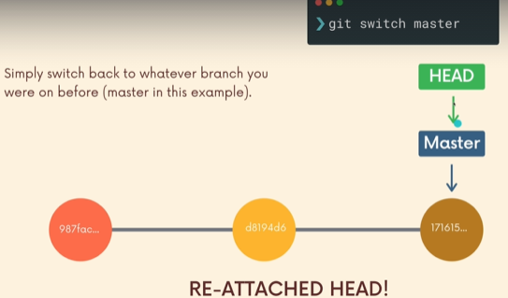

So above, we time travel back and time travel foward.

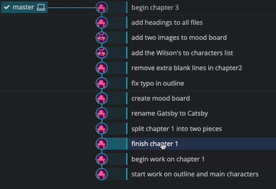
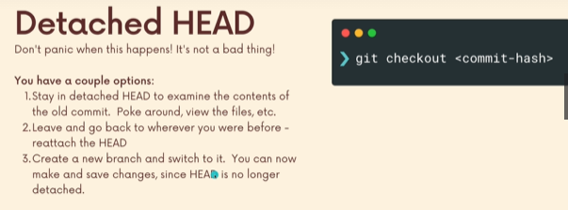
I wanna rewrite my book from chapter 1, but i dont wanna lost stuff.

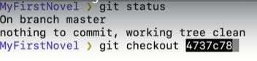

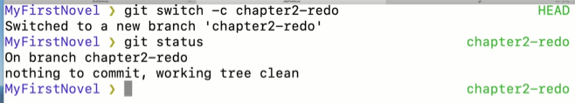
Now, you have created a branch and you work seperately.
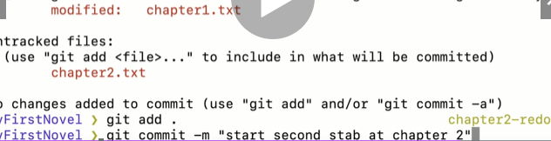

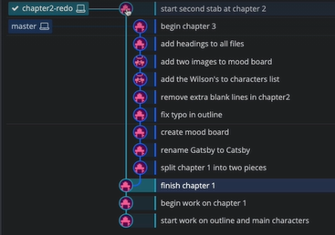
You can switch and go back to your time to your future which is your past.

Referencing Commits Relative to Head
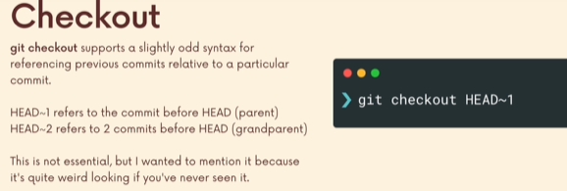
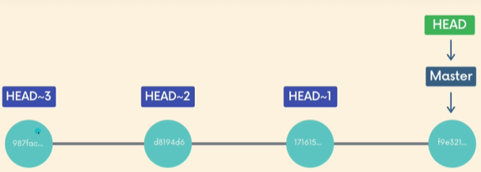

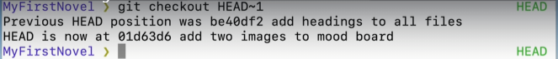
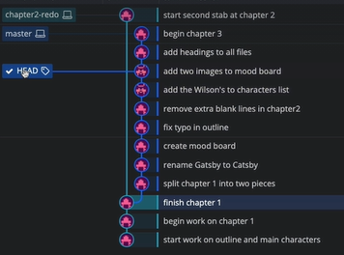

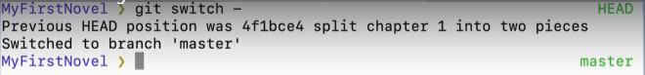
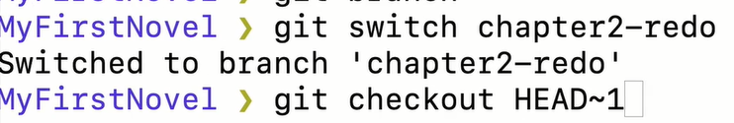

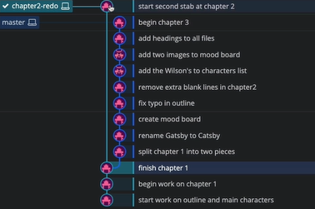

Discarding Changes With Git Checkout
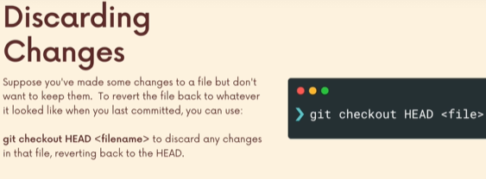
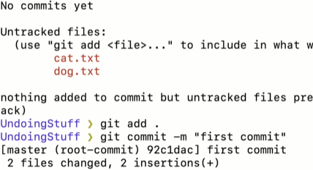

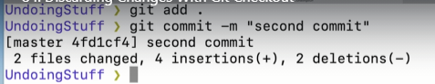

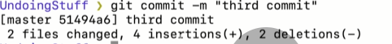

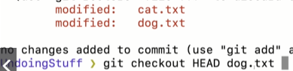

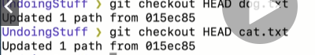

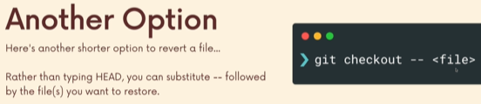

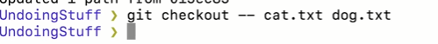

Un-Modifying with Git Restore
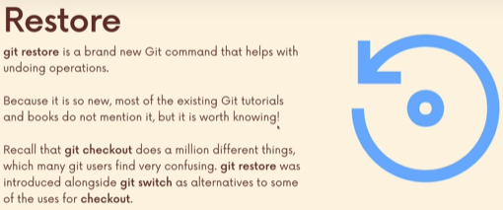

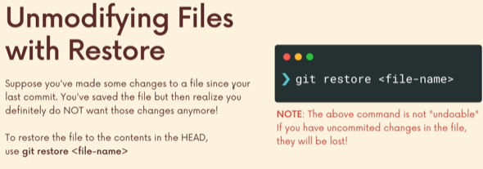


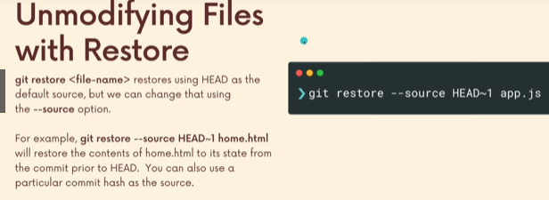
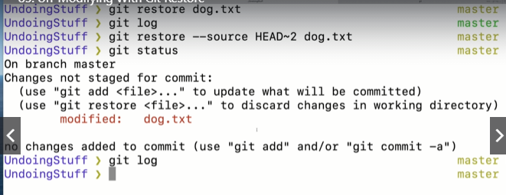
We havent time travelled. Only our file is time travelled.
We can bring that file to the most recent update.
Instead of Head~2 we can specify a commit hash.

Un – Staging changes with Git restore
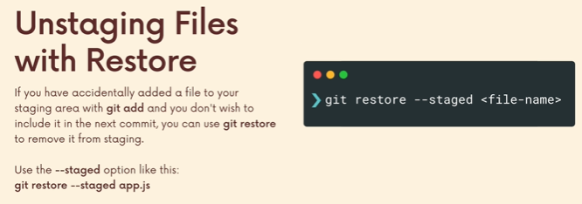
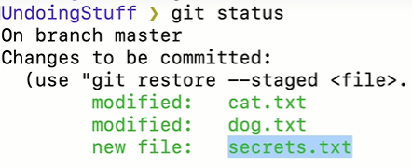

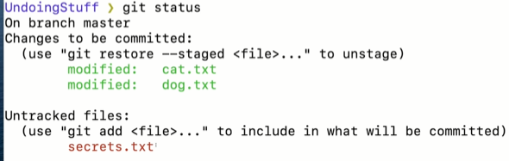
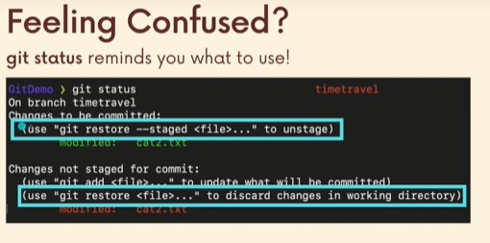

Undoing commits with Git reset
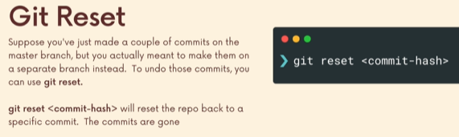
There are two types of reset there is regular reset, plain reset.
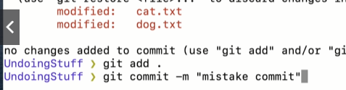

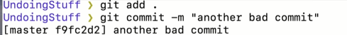

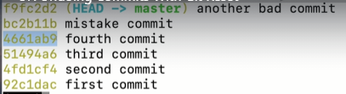

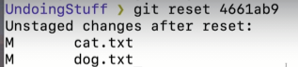

You might think the changes are gone, but they actually not.
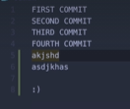
What we did is a plain reset, that removed the commits. The Changes are still in our working directory.
All it did is, it removed the commits.
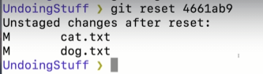

From here, you do git diff to compare files in local working directory and the recent commit(which was old, but its now new).
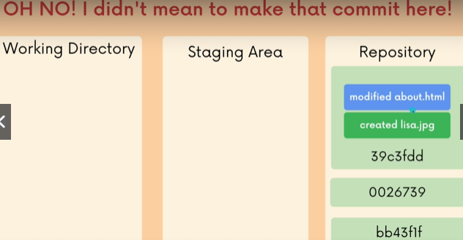

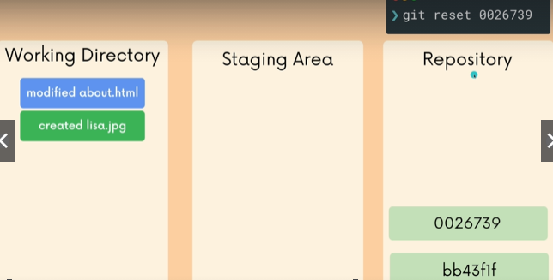

Or we can take those changes with me to another branch.
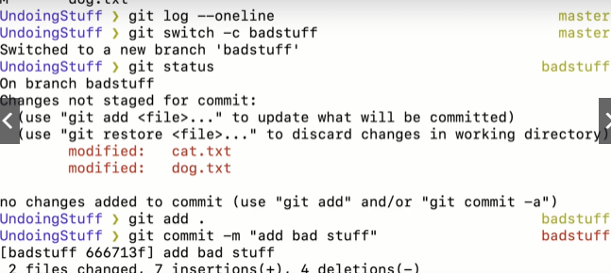
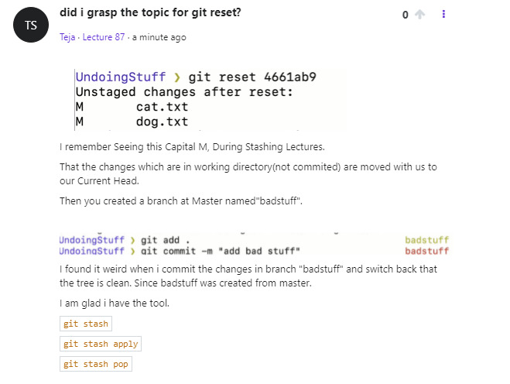

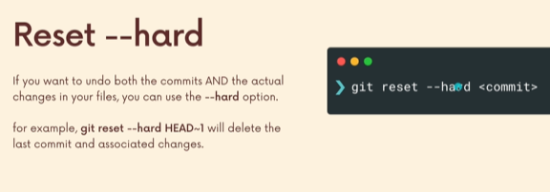
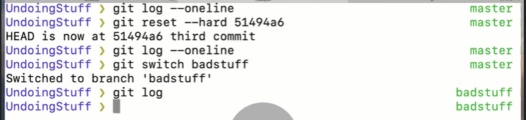

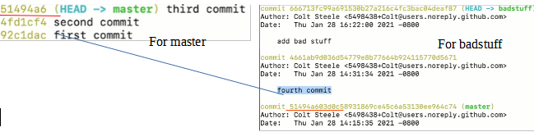
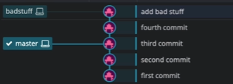
Fourth comit is still there for badstuff.

Reverting Commits With Git revert
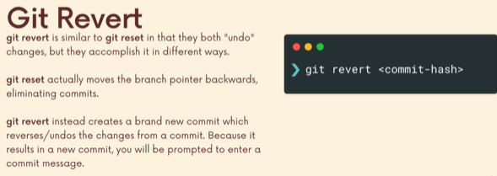
Undoing commits can be a problem when u collaborating with other people.
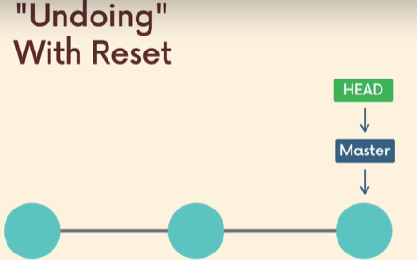

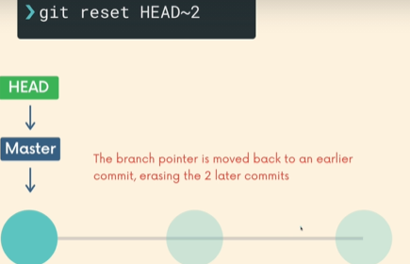

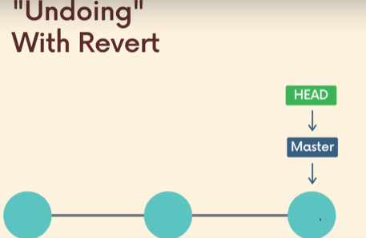
Lets say i made a mistake

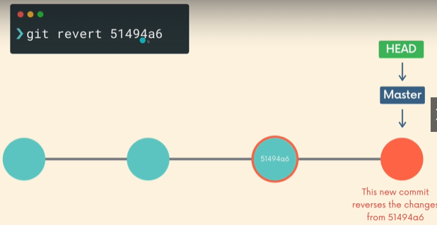

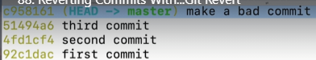

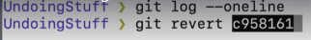
it opens the editor for us to write a commit message.
Instead of doing git reset (regular) and then creating a new branch and commiting the local changes. Aka it gets removed from master and its on a new branch.
You can keep the changes in the master branch and create a new commit explaining that you have revert the changes from last commit.
That is git revert.

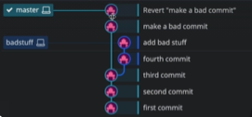
You can do reset for your own work.
But not for colloborators.
Instead, use git revert.

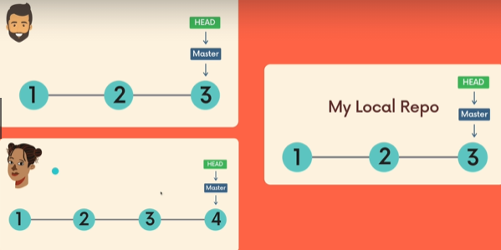

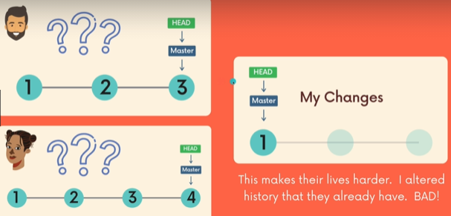
Cuz i altered the branch they were working on.
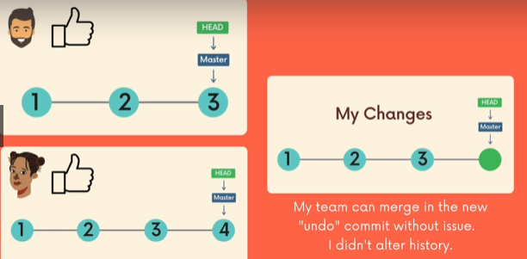

Reverting a commad may sometimes lead to a conflict. Where you need to go to a file and decide what you wanna keep or allow or both and resolve conflicts.

